Using DBPrimary

Dear Parents and Carers,
For those of you who do not already know, at Perryfields Infant School we have a fantastic learning platform called DBPrimary, which the children can use to email, blog, tackle learning games and save work.
Each child is given its own username and password to access this platform, and these have been stuck inside their reading records. If your child does not have one, please let their class teacher know. The address is written in small blue writing at the bottom of the card. The username is usually their first name and the first letter of their surname (without a space or capital letters) and the password is 3 pictures.
/joeb
joeb
Joe Bloggs

Username address of platform password
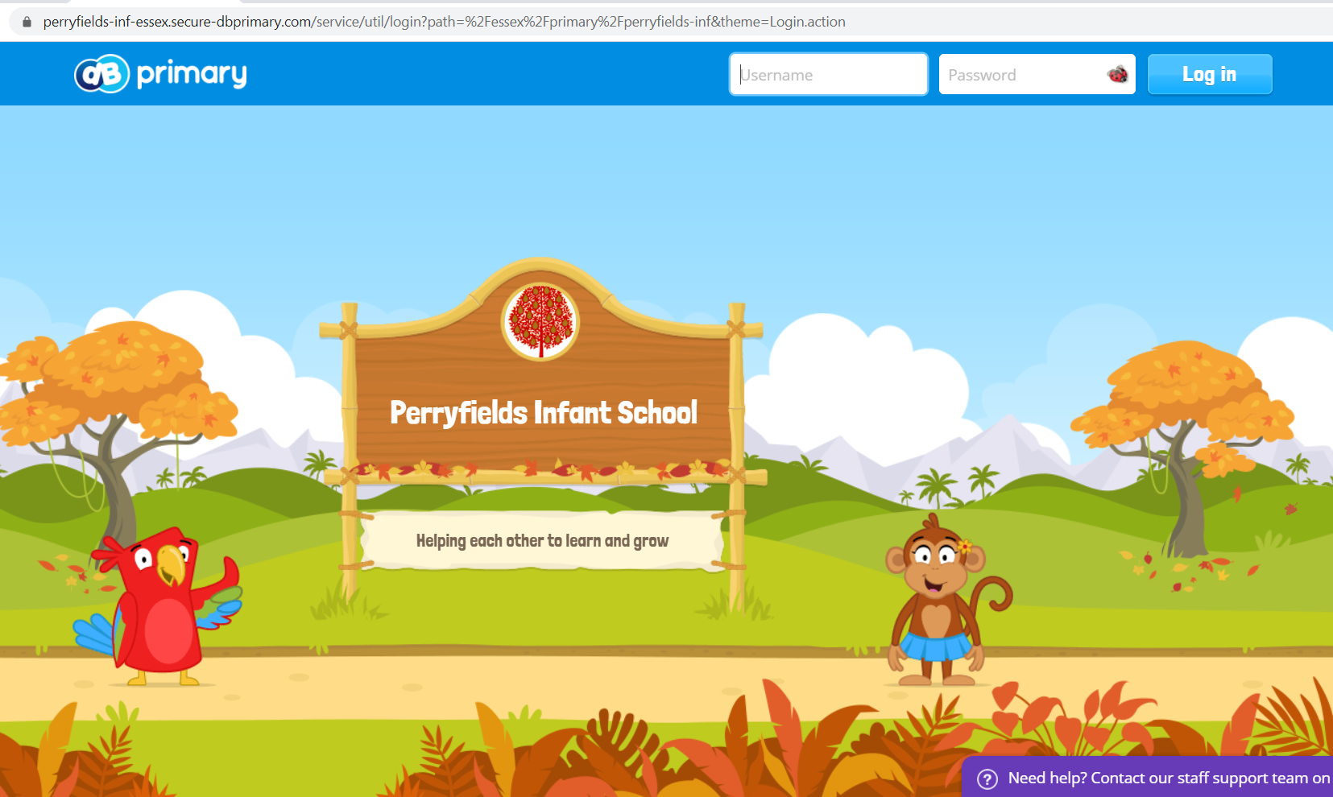
Return after entering username and pictures will appear!
This is an example of the child’s own page.
Work can be saved here. Emails can be accessed here.
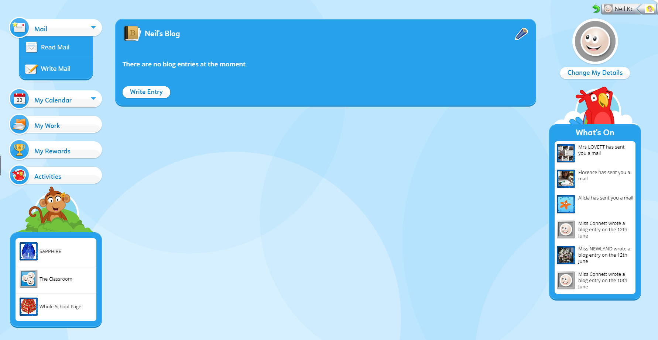
This is where to access the class page. Games are accessed here.

Here is an example of a class page.
The class blog can be accessed here.
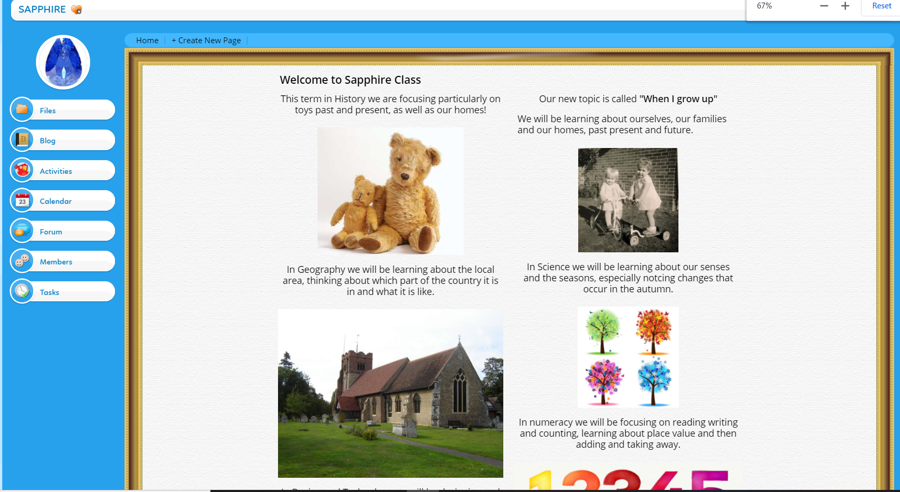

If you upload work into the Files section of the class page, your child’s teacher will get a notification that there is work to be approved, so this is the best place to save work!

