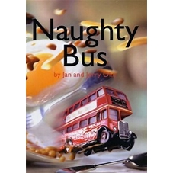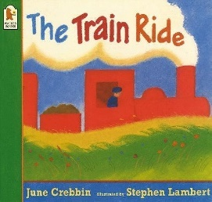

Personal, Social and Emotional Development

Core Values – Honesty and Perseverance

The Zones of Regulation

Emotional vocabulary

Oral Health

Healthy Eating

Physical Development

Gross Motor- co-ordination and balance, large and small apparatus

Fine Motor- Dough Disco, Handwriting, using a range of tools including scissors

PE – Dance and Gym

Spring Term

Communication and Language

Learning new vocabulary

Conversational skills including listening and speaking activities

Answering how and why questions

Speak using full sentences

Retell stories in a sequence

Expressive Art and Design

Role play/ Acting out a story

Junk modelling buses/ trains

Painting buses/trains

Drawing buses/trains

Making track/road patterns

Making/flying kites

Mathematics

White Rose Maths

Combining amounts

Exploring numbers to 10 – using ten frames, introducing number bonds to 10

Comparing mass, capacity, length and height

3d shape and their properties

Exploring in the maths area

Literacy

Focus author – Jill Murphy

Focus books – Naughty Bus by Janet and Jerry Oke and The Train Ride by June Crebbin

Non fiction texts

EWI (Early writing instruction) Writing in sentences using spaces and full stops

Phase 3 phonics

Understanding the World

Floating and sinking / Freezing and melting

Flying kites

Winter/ Spring Easter/ Holi festival/ Chinese New Year

London

Modes of transport

EYFS Medium Term Plan

Spring 2024