Some spelling activities to try at home;

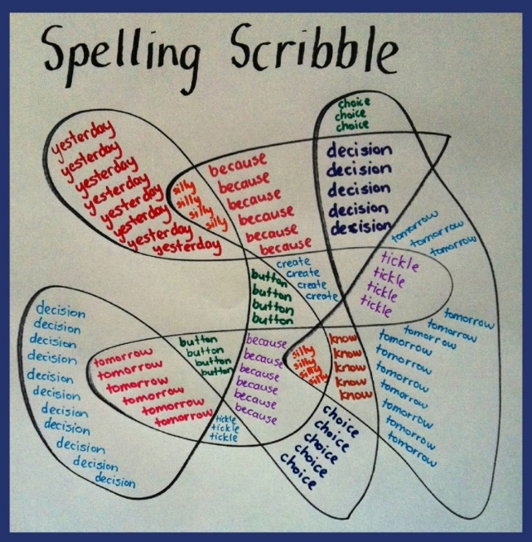
- Spelling Scribble

- Look, Say, Cover, Write, Check

- Roll and spell - writing
- Write the word with your other hand
- Write the word as fast as you can
- Write the word with your eyes closed
- Write the word in a fancy way
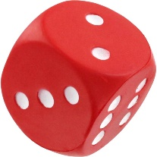
- Write the word in capitals

- Roll and spell – spelling aloud
- Spell the word in your robot voice
- Spell the word in your grumpy teacher voice
- Spell the word in the Queen’s voice
- Spell the word in your monster voice
- Spell the word in the caretaker’s voice
- Spell the word in your opera voice

- Un-jumble the words – choose any spelling rule
wo (sounding wer) words
drows
dorlw
wrok
twrho
mrow
ripowsh

- Guess the word to fit the shape

- Backwards Words - Guess the word

sdrawkcab

- Be the Teacher - Correct the spellings

catt

rabbet

buck

trayn

klok

- Guess what!

Play charades with your words. Choose a word and act it out. The other person guesses the word by writing it down. You can score 1 point for guessing the word and 1 point for spelling it correctly.

- Words within words

Write each spelling word and then write at least two words made from the same letters that is hidden inside the word.

Example: slide

side lie lid led

- Spelling train

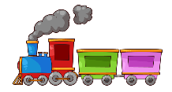
Read a spelling word aloud and write it down. Using the last letter in that word, write another word beginning with that last letter. Continue the train using the last letter of the word. Stop at ten words.

Example: cat

tan

nap

pot

- Word Stairs

- Shannon's Game

Start by writing the first letter of a word. Then put down dashes to represent the other letters. Allow ten guesses for the next letter. If there is no correct guess, put the letter in and go on to the next. Continue until the whole word is completed.

So, for example:

q-------
qu------
que-----
ques----
quest---
questi--
questio-
question

