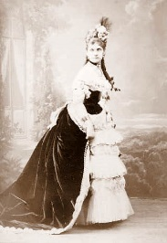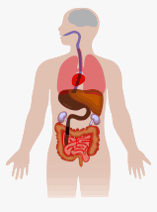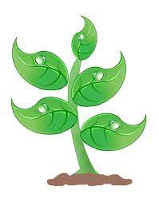

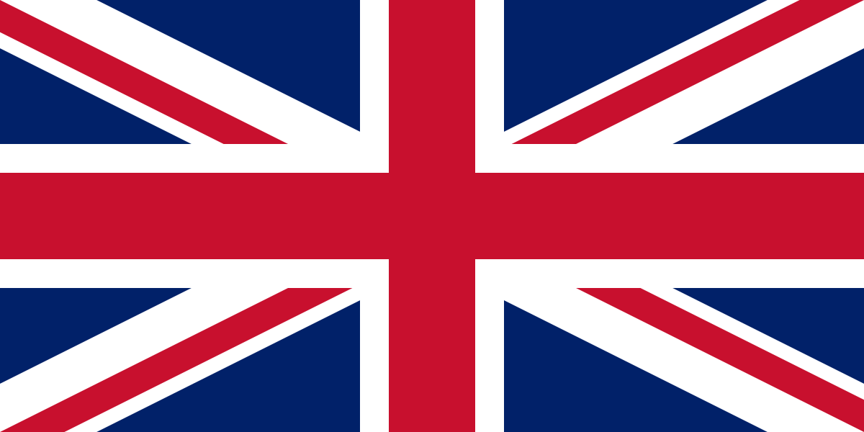

**History – Helene de Pourtales**

**The first Olympic Games to allow women was the 1900 Games in Paris. Hélène de Pourtalès became the first woman to compete and the first female champion, winning 2 sailing events.**

**Since the 1900 Olympic Games, more and more women started competing, and more and more events for women’s sports have been added.**

**Helen was born on April 28, 1868, in New York City.**

**Helen was a crewmember of the Swiss boat *Lérina*, which won the gold medal in the first race of 1–2 ton class and silver medal in the second race of 1–2 ton class.**

**She died on November 2nd, 1945 and was 77 years old when she passed away.**

**Sending Emails and Coding**

**Logon to DB primary with your username and password.**

**Go to the mail Icon (picture) and click on ‘Write Mail’.**

**Click on the address link and chose the person to send it to.**

**Then write the subject of your email (what it is about), type your email and press send!**

**Geography – To compare the UK and Brazil.**

**The UK**

**The United Kingdom is made up of four countries (England, Scotland, Wales and Northern Ireland).**

**The capital city of England is London, the capital city of Scotland is Edinburgh, the capital city of Wales is Cardiff and the capital city of Northern Ireland is Belfast.**

**The official flag is the Union Jack.**

**The population (number of people living there) is around 64 million!**

**Currently the UK is ruled by King Charles III.**

**The currency (money) in the UK is the pound sterling.**

**Brazil** 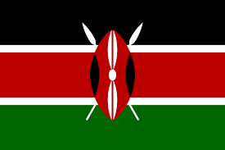

**Brazil is the largest country in South America and the fifth largest nation in the world.**

**The Brazilian landscape is very varied. It is best known for its dense forests, including the Amazon, the world's largest jungle, in the north. But there are also dry grasslands (called pampas), rugged hills, pine forests, sprawling wetlands, immense plateaus, and a long coastal plain.**

**Northern Brazil is dominated by the Amazon River. The Amazon is not one river but a network of many hundreds of waterways.**

**Science – Plants and the Human Body**

**Plants need light, water, warmth and nutrients to grow.**

**Roots – suck up water and nutrients from the soil.**

**Stem – transports water and nutrients.**

**Leaves – make food for the plant from sunlight (photosynthesis).**

**Flower head – attracts insects to carry/collect pollen.**

**The human body is made of cells, tissues, organs and systems.**

**The human body has 206 bones and 7 vital organs (brain, lungs, liver, bladder, kidneys, heart, stomach and intestines).**

**An adult has 32 teeth and they are coasted in a special substance called enamel.**

**The Road to Paris Knowledge Organiser**

**Year 2 – Summer Term**