
Star of the Week
George Ford
George Ford (born 16 March 1993) is a rugby union player who plays at fly-half for Leicester Tigers and England. Born in Oldham, Greater Manchester. 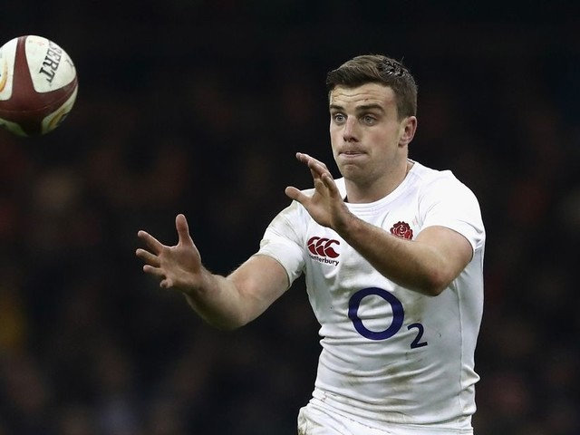
Physical Challenge:
If you haven’t got a rugby ball, make a homemade rugby ball by stuffing a small plastic bag with paper or socks. Using a two-handed swinging action, pass the ball backwards. The player with the ball runs forwards to then pass the ball backwards. Play it in the park too.

Research Challenge:
Watch a short clip of Rugby Union and Rugby League games. What is the difference in the rules ?
Ow may player in a Rugby Union team?

Creative Challenge:
Make up a rugby skills game that includes passing backwards and running forwards.

Please look at the weekly sheet challenges below and don’t forget to look on the website for video examples of the challenges and the parent zone tab for more activities.
Click on www.chelmsfordssp.com
Physical Family Games
KS1& KS2 Blast the Bag
Go to the website or click on here to see the game : https://youtu.be/o79gBiPNkQc
A sending, aiming game for anyone to play. You need a plastic bag filled with air and tied loosely at the top, 4 or 5 pairs of rolled up socks per team member.
Start with two players standing either side of the plastic bag. The players take three or four giant steps backwards, so the bag remains in the middle of the area and they are both equidistant from the bag.
Player A X X Player B
Plastic Bag
On the command “go” each player tries to blast the bag towards their opponent using their socks. The winner is the player who has the ball nearest to their opponent after all the socks have been thrown.
Tactical questions :
Do you throw fast or slow ? Do you throw lightly or strongly ? Do you use all your socks in one go or wait to see what your opponent is doing? Do you throw overarm or underarm?
Differentiation:
Space - change the distance you are from the bag
Task – Can you play sitting, standing, throwing with your non dominant hand. Play it football style by kicking the socks towards the bag?
Equipment – use a beach ball or balloon as the target , use tennis balls to throw
People – play in pairs or with all the family in teams

KS2 Sock Wars
For this game you will need a long sock per player. Each player tucks a sock in the waistband of their trousers or shorts, so that it is hanging down at the back.

Player A travels quickly from one end of the room or garden, to the other end. Player B stands in the middle and tries get Player A’s sock before they reach the other end. One point per sock collected. Change over and play so that each player has three goes.
Differentiation:
Space – make the playing space larger or smaller to suit your needs
Task – change the rules and the travel tasks to make it easier or harder
Equipment – Mark out a start and a finish line
People – play with two people or more if you have more in your family
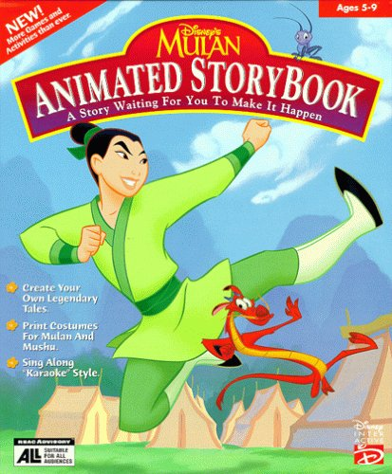
Creative Activity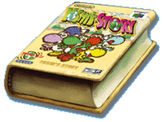
KS1 Active Story Time
Verb= An action or doing word or feeling word e.g. jumped
Adverb = A word that describes the verb e.g. quickly
Choose your favourite story and read this by yourself or with someone else in the family.
Every time you read a verb, perform the action together e.g. the dragon flew through the sky. How creative can you be with your movements?
Challenge yourself to find the adverbs and consider how to move e.g. the dragon flew softly through the sky.
Can you make up a moving imaginative sentence of your own? Perhaps Video you doing and saying it? Send it to your teacher or your friends and family if you are allowed?
Synonym Skipping
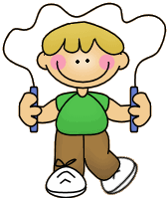
Synonym : A word or phrase that means exactly or nearly the same as another word or phrase
Play in pairs or as a family.
Everyone needs a real or imaginary skipping rope.
One person starts by shouting out an adjective (describing word e.g.small)
Everyone starts skipping or imaginary skipping and takes it in turns to shout out a synonym for the adjective e.g tiny, little, titchy
Person who cannot think of a word loses that game. Play again.
Challenges:
You can play the game using different themes; e.g football teams, numbers in the 6 x table, girls names, flowers, food.
You can do different exercises as you play – star jumps, jogging, balancing .
Make up your own rules.

Orienteering Challenge
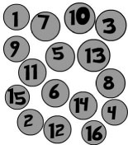

Hidden Numbers

You will need 10 playing cards numbered 1 – 10
A powerful exercise for learning how to work together, communicate
and seek to improve performance in pairs or small team.
Randomly lay out up to 10 numbered playing cards face down
in a set area. Create a starting/finish point up to 5 – 7 meters away.
As a pair or team you are trying to do this challenge in the fastest time. Try it once and then discuss how to be faster.
You must pick up all the numbered spots as fast as you can in the correct order. Taking it in turns the first player comes out to select a card. If it is the desired number, they bring it back if not they replace it and come back, the next team member then goes.
What was your fastest time?

Variations
Make letters or use scrabble letters and lay out the letters face down. You need to bring them back in the correct order to spell a word of your choice in the fastest time. Discuss how to be faster and try again. What strategies do you use ?
Make more numbers and using numbers try an appropriate maths problem and the answer number must be brought back. Answers could be several digits needing more numbers to be found.
Make up your own number problems for another player and see how quickly they find the digits?

Processing Ideas
What skills did it take to be successful as a pair or team?
What creative solutions were suggested and how were they received?
Did everyone listen to each other’s ideas? What key factor led to an improvement in time?

Fitness Challenge
Balance is a key component of fitness. This weeks challenge is based all around balance.
All you need to take on the challenge is a small amount of room and a timer, and something to catch for the harder challenges.
The challenges:
1 – See how long you can stand on one foot, remember to put your arms out wide and look at something in front that isn’t moving this will help you balance.
2 – Can you now make shapes or move your body forwards and backwards whilst keeping balanced?
3 – Can you catch a ball (could be a pair of rolled up socks) whilst keeping balanced?
4 – make the catches harder by getting thrown to your sides or higher and lower whilst trying to keep your balance. See how many catches you can do before you have to put your other foot down.
Remember to try the challenges on both sides of your body. Below are some images of the different challenges. You can also go to the www.chelmsfordssp.com website to see the full video on this fitness challenge.

Skills Challenge

This weeks skills challenge is called ‘Ready, Aim, Fire’ . This is a great practice to work on hand eye co-ordination.
You will need:
A tennis ball (any ball that can be hit is fine)
A bat (this could be cricket bat, tennis racket , your foot anything you can strike a ball with )
Cones ( or anything that can be used to make a gate as a target)
See the picture below of how to set up the practice.
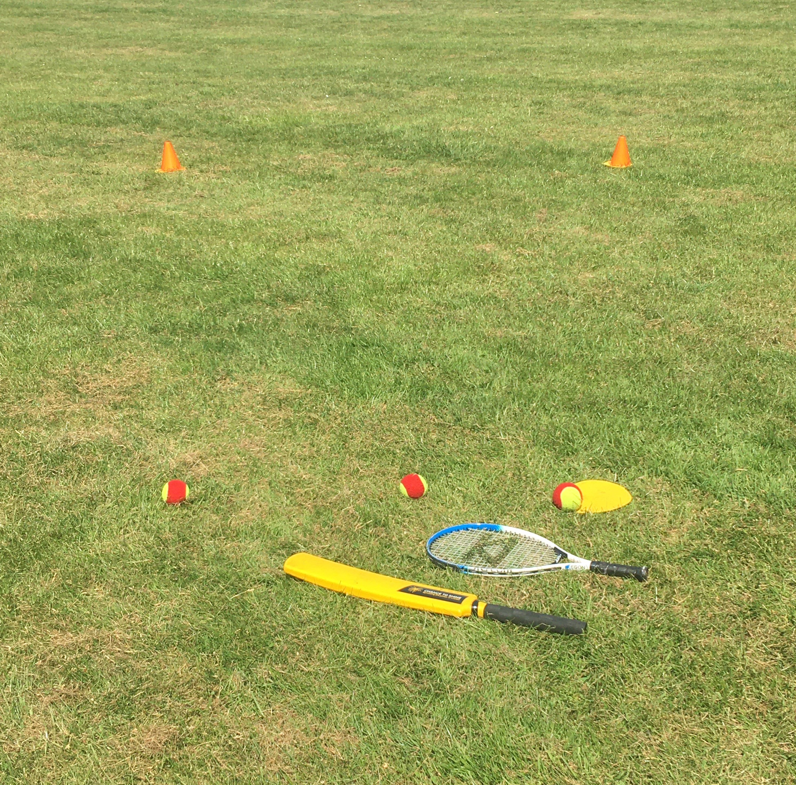
Target starts at 3m wide
Hitting zone
Rules.
You have to strike the ball through the gate, you have 3 attempts. If you score 2 or 3 times you must make your target smaller. If you score 0 or 1 time you need to make your gate bigger.
Start with a 3m wide gate and adjust from there.
Challenges:
1 -Can you now do the same practice but with the ball dropped in front of you?
2 – Can you hit the ball fed to you from in front now?
To see the full video on this skill challenge visit www.chelmsfordssp.com and look on the parent zone.

