**Christmas Day**

[](https://www.google.com/url?sa=i&url=https%3A%2F%2Fwww.istockphoto.com%2Fillustrations%2Ffamily-opening-christmas-presents&psig=AOvVaw2ja_5LUTbEkEfcfjJhpl1L&ust=1609673601888000&source=images&cd=vfe&ved=0CAIQjRxqFwoTCNjgkaGU_e0CFQAAAAAdAAAAABAD)[](https://www.google.com/url?sa=i&url=https%3A%2F%2Fwww.pinterest.com%2Fpin%2F382594930823904944%2F&psig=AOvVaw1j2c0lE_9JXo74cNjns96S&ust=1609673644230000&source=images&cd=vfe&ved=0CAIQjRxqFwoTCMCnzbCU_e0CFQAAAAAdAAAAABAD)[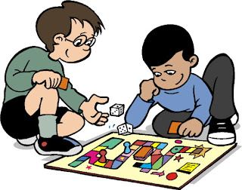](https://www.google.com/url?sa=i&url=http%3A%2F%2Fclipart-library.com%2Fplay-games-cliparts.html&psig=AOvVaw3FpOZ-mv8Kqh7qqPiCgIOC&ust=1609673682553000&source=images&cd=vfe&ved=0CAIQjRxqFwoTCNDymMKU_e0CFQAAAAAdAAAAABAD)[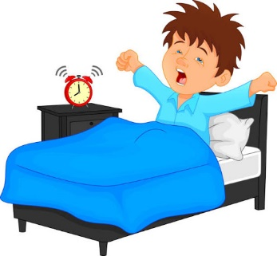](https://www.google.com/url?sa=i&url=http%3A%2F%2Fclipart-library.com%2Fwake-up-clipart.html&psig=AOvVaw030DlIGUji6huDs52DEr8i&ust=1609673544104000&source=images&cd=vfe&ved=0CAIQjRxqFwoTCMjJrISU_e0CFQAAAAAdAAAAABAD)

[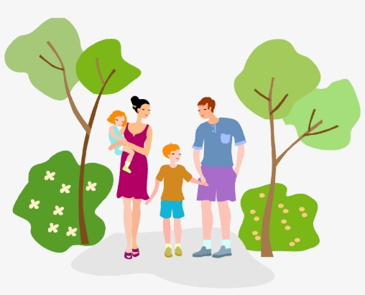](https://www.google.com/url?sa=i&url=https%3A%2F%2Fwww.pngkey.com%2Fdetail%2Fu2q8t4w7t4q8t4w7_hiking-clipart-nature-walk-walking-family-clipart%2F&psig=AOvVaw3ZjKPzeA76LpywX3KR2ld9&ust=1609673751861000&source=images&cd=vfe&ved=0CAIQjRxqFwoTCLiPqeSU_e0CFQAAAAAdAAAAABAD)[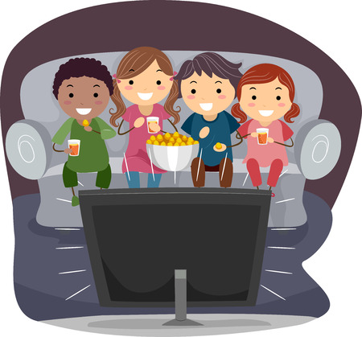](https://www.google.com/url?sa=i&url=https%3A%2F%2Fwww.123rf.com%2Fclipart-vector%2Fwatching_movie.html&psig=AOvVaw1cwyxkvvz_TjfElKr6T3rU&ust=1609673719332000&source=images&cd=vfe&ved=0CAIQjRxqFwoTCMiD-tOU_e0CFQAAAAAdAAAAABAD)

Remember to keep your writing in the **past tense** as it has already happened.

Try to use some **time words** to begin each sentence (First/Next/Then/Finally/After that.)

Remember to include some **conjunctions** to add more detail to each sentence (and, but, because).

Don’t forget to use **punctuation** - capital letters, full stops, exclamation marks or maybe even a comma for a list.

Try to think of **two sentences** for each picture or add some of your own ideas to the word bank to help you. ☺

went for a walk

watched a film

played games

Christmas Dinner

opened presents

woke up