Tuesday 9.1.21
Longer and shorter

1. Use the words taller and shorter in the sentences to compare the height of the man and the boy.
The man is than the boy.

The boy is than the man.

2. Use the words longer and shorter in the sentences to compare the length of the blue pencil and the red pencil.

The blue pencil is
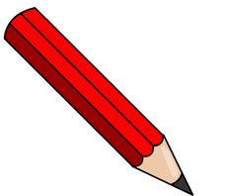
than the red pencil.

The red pencil is
than the blue pencil.

Which pencil is the longest and which is the shortest?

3. Dan is comparing items at school.
He says the glue stick is the shortest. Do you agree? Explain your answer.
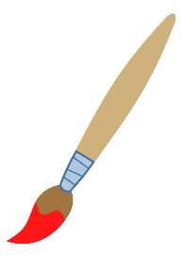
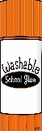

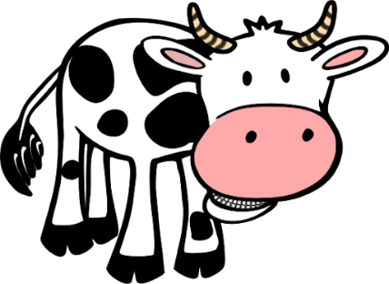
4. Ava is thinking of an animal. She says my animal is the shortest. Which animal is Ava thinking of?
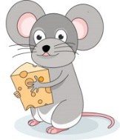

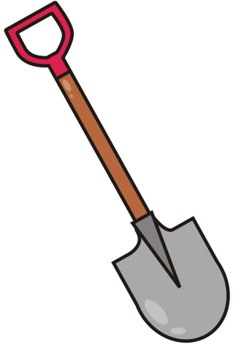
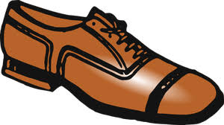
5. Use the items below to make comparison statements. Use is shorter than and is longer than. Find 3 possibilities.

6. Adam is thinking of two animals. He says my animals are shorter than the pig. Which two animals is he thinking of?
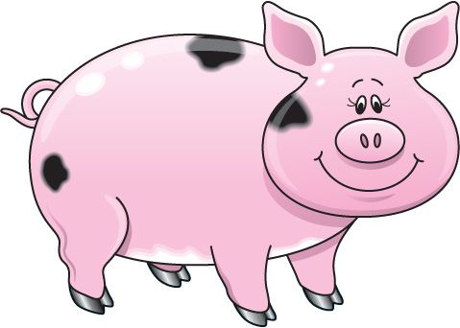
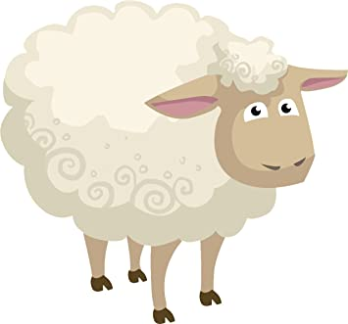
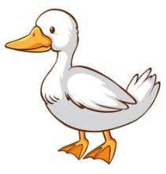
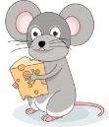
Challenge: Draw 4 things in order from shortest to tallest.

