[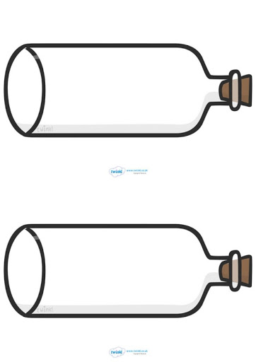](https://www.google.com/url?sa=i&url=http%3A%2F%2Fclipart-library.com%2Fmessage-in-a-bottle-outline.html&psig=AOvVaw0vITkxt-wK98sJIMWB7d_B&ust=1594469990728000&source=images&cd=vfe&ved=0CAIQjRxqFwoTCLDcurPWwuoCFQAAAAAdAAAAABAD)On my desert island I can see…