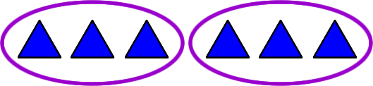
There are ___ equal groups with ___ in each group.
___ +___+___+___ =12

There are ___ equal groups with ___ in each group.

___ +___+___ =12

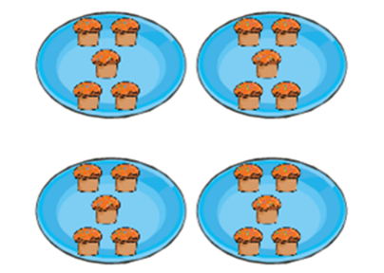
There are ___ equal groups with ___ in each group.

___ +___+___+___ =___
There are ___ equal groups with ___ in each group.

___+___+___+___+___+___=___
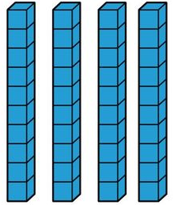
There are ___ equal groups with ___ in each group.

___ +___+___+___+___+___+___+___ =___

Fill in the table.
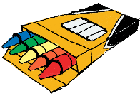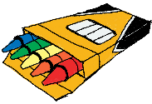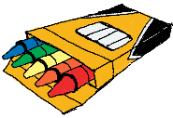 | Draw it.
Say it.  There are ___ equal groups with ___ in each group.  There are _____________. | Add it.  ___+___+___+___+___+___ =___

