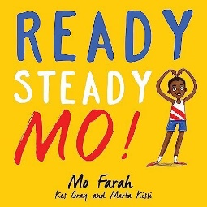

Physical Development

Gross Motor- co-ordination and balance, Throwing and catching

Fine Motor- Handwriting, using a range of tools including scissors

PE – Athletics, Sport’s Day, Sports week

Take part in a new sport each week

Expressive Art and Design

Make/ draw the Eifel tower

Perform a dance for an opening ceremony

Draw paint/famous athletes

Paint/draw/design flags

Personal, Social and Emotional Development

Core Values – Self Belief and Courage

The Zones of Regulation - Consider the needs of others

Healthy Eating and the Importance of exercise

Team work

Summer Term

Road to Paris

Communication and Language

Learning new vocabulary

Use talk to organise thinking

Explain why things might happen

Speak using correct tense

Retell stories in a sequence from memory

Mathematics

White Rose Maths

Making teen numbers

Addition and Subtraction

Shape

Time and Measure

Number bonds

Exploring in the maths area

Understanding the World

Olympics – Study famous athletes including Mo Farrah, Usain Bolt, Jessica Ennis

Olympic cities - Paris and London

Countries who participate in the Olympics

Animals from around the world

EYFS Medium Term Plan

Summer 2024

Literacy

Focus author – Kes Gray

Focus book – Ready Steady Mo by Kez Gray

EWI (Early writing instruction)

Recap on Phase 3 phonics

Writing sentences using finger space, capital letters, full stops

Simple story writing