Friends
By Abbie Farwell Brown

How good to lie a little while
And look up through the tree!
The Sky is like a kind big smile
Bent sweetly over me.

The Sunshine flickers through the lace
Of leaves above my head,
And kisses me upon the face Like Mother, before bed.

The Wind comes walking over the grass
To whisper pretty things;
And though I cannot see him pass,
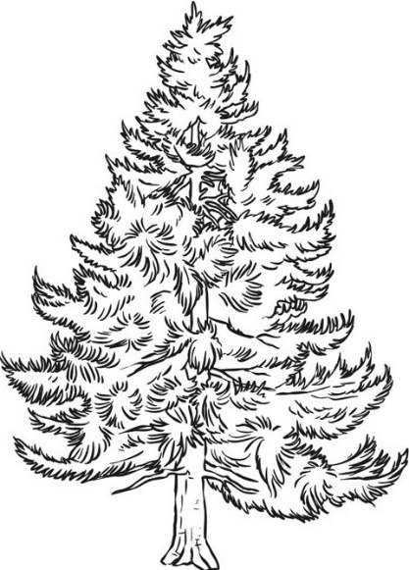
I feel his careful wings.

So many gentle Friends are near
Whom one can scarcely see,
A child should never feel a fear,

Wherever he may be.

