Maths Activity Sheet
Today’s activities are all about counting in 2s, forwards and backwards from different places. Use your grid from Monday if you need to.

- Count in 2s backwards to complete this number track.
 |  |  | 40 | 42 | 44 | 46

If you continued to count backwards, would you land on 25?
Why do you say that?

- Count in 2s forwards to complete this number track.
13 | 15 | 17 | 19

If you continued to count forwards, would you land on 50?
Why do you say that?

- Is this true always, sometimes or never?
When you count in 2s, you will only use digits 2, 4, 6, 8 or 0.

Give some examples to prove what you say!

- Rosie counts back from 50 in 2s.
50, 48, 46, 44
Adam counts forward from 12 in 2s.
12, 14, 16
They say their numbers at the same time.
Who will say 30 first?

- There are 26 ice skates whizzing round the ice rink. How many children does that mean there are skating?

- There are 17 chickens pecking in the farmyard. All the chickens have 2 feet! How many chicken feet are in the farmyard?
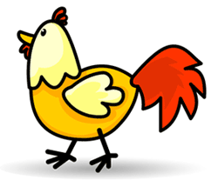

*Now write a “counting in 2s” problem of your own (including the answer)!

