[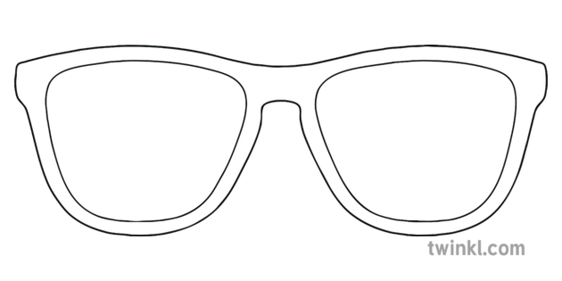](https://www.google.com/url?sa=i&url=https%3A%2F%2Fwww.twinkl.co.in%2Fillustration%2Fsunglasses-outline-summer-shades-eyes-sun-holidays-ks2&psig=AOvVaw0_0QlA85dqWTQ8mhUeNCzB&ust=1594467890369000&source=images&cd=vfe&ved=0CAIQjRxqFwoTCKiK7M3OwuoCFQAAAAAdAAAAABAJ)

**During the Summer holidays I would like to…**