Tuesday 14th December – Topic Work
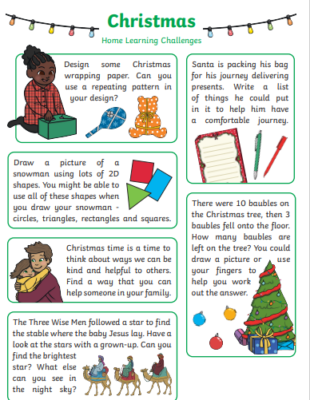
Pick at least one of the following activities to complete at home. If you would like a challenge, you can complete all of them! Upload a photo of your work to DB Primary.

