Meerkat Facts
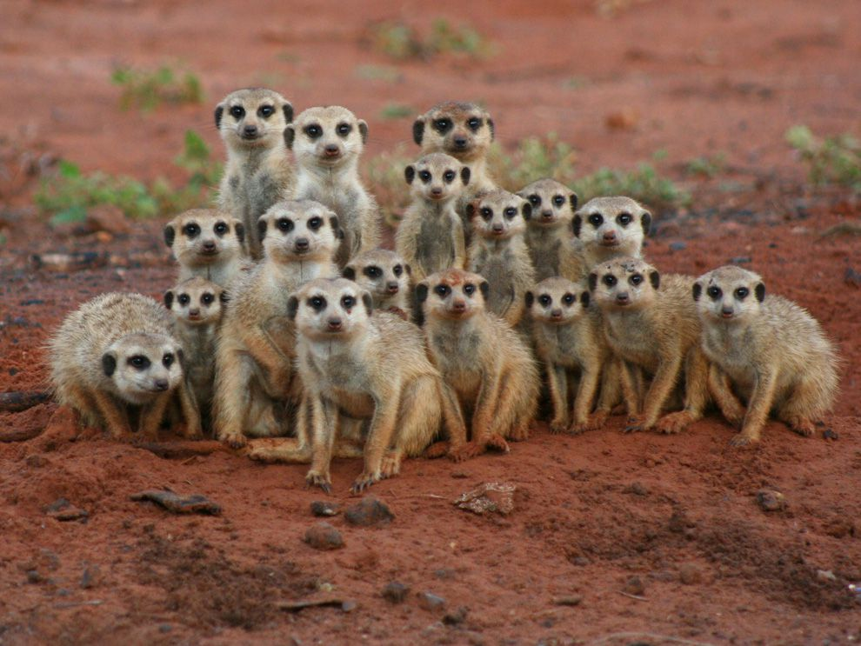
You may have seen meerkats at the zoo. They are one of my favourite animals to watch! Did you know that, in the wild, they live in the desert?
They are super cute and have bushy, brown-striped fur, a small pointed face and large eyes surrounded by dark patches. These dark patches act like sunglasses and protect their eyes from the sun.
They like to live together as a group, called a mob or gang. They use their long, sharp claws to dig an underground burrow. This keeps them out of the hot sun and safe from all the animals that may want to eat them (predators).
Meerkats only go outside during the daytime. They start looking for food as soon as the sun comes up in the morning. They use their good sense of smell to help them find their food.

