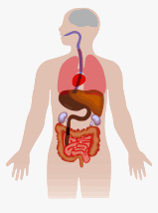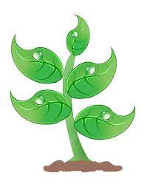

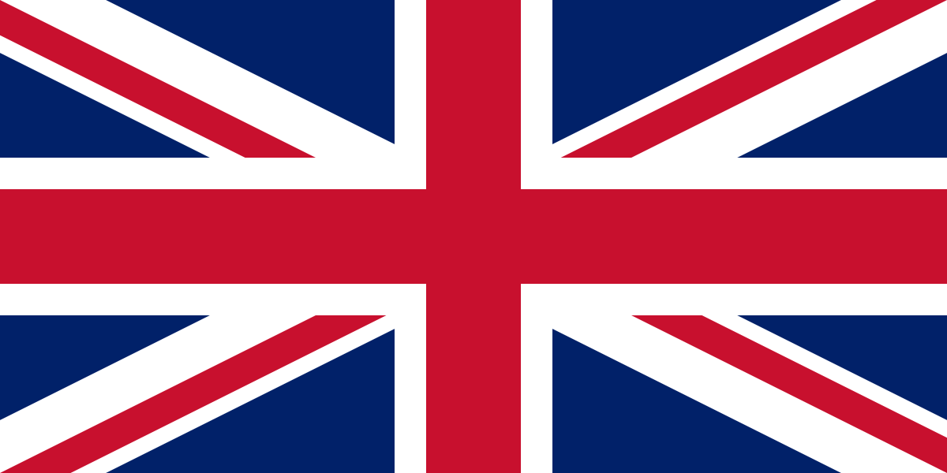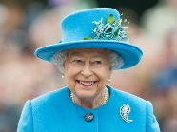

**Sending Emails and Coding**

**Logon to DB primary with your username and password.**

**Go to the mail Icon (picture) and click on ‘Write Mail’.**

**Click on the address link and chose the person to send it to.**

**Then write the subject of your email (what it is about), type your email and press send!**

**Geography – To compare the UK and Kenya.**

**The UK**

**The United Kingdom is made up of four countries (England, Scotland, Wales and Northern Ireland).**

**The capital city of England is London, the capital city of Scotland is Edinburgh, the capital city of Wales is Cardiff and the capital city of Northern Ireland is Belfast.**

**The official flag is the Union Jack.**

**The population (number of people living there) is around 64 million!**

**Currently the UK is ruled by Queen Elizabeth II.**

**The currency (money) in the UK is the pound sterling.**

**Kenya** 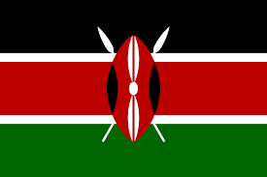

**Kenya is a country in East Africa with coastline on the Indian Ocean. It is made up of savannah, lakelands, t he dramatic Great Rift Valley and mountain highlands. It’s also home to wildlife like lions, elephants and rhinos.**

**The capital city of Kenya is Nairobi. The currency is the Kenyan shilling.**

**The Kenyan flag is a tricolour of black, red and green with a red, white and black Massai shield and two crossed spears.**

**The population of Kenya is around 55 million people!**

**Queen Elizabeth II is the official reigning monarch of Australia.**

**The currency in Australia is the Australian dollar.**

**Science – Plants and the Human Body**

**Plants need light, water, warmth and nutrients to grow.**

**Roots – suck up water and nutrients from the soil.**

**Stem – transports water and nutrients.**

**Leaves – make food for the plant from sunlight (photosynthesis).**

**Flower head – attracts insects to carry/collect pollen.**

**The human body is made of cells, tissues, organs and systems.**

**The human body has 206 bones and 7 vital organs (brain, lungs, liver, bladder, kidneys, heart, stomach and intestines).**

**An adult has 32 teeth and they are coasted in a special substance called enamel.**

**Jubilee Knowledge Organiser**

**Year 2 – Summer Term**

**History – Queen Elizabeth II Coronation**

**Queen Elizabeth was born on the 21st April 1926.**

**She was crowned Queen on the 2nd June 1953 and 20 million people watched her coronation on television.**

**She is the longest reigning monarch in Great Britain.**

**Her father was King George VI.**

**Queen Elizabeth II was married to Prince Phillip for 73 years and has 4 children (Prince Phillip, Prince Edward, Princess Anne and Prince Andrew).**

**As queen, she has been served by 14 UK Prime Ministers.**

**In 1945 Queen Elizabeth II became the first female member of the Royal Family to join the Armed Services as a full-time active member.**

**On 2nd June 2022 the Queen will celebrate her Platinum Jubilee to celebrate the fact she has been on the throne for 70 years!**