Tuesday 14th December
White Rose Maths video. Here is the link for today’s video. If this does not work then please follow the instructions below to find the video.
Session 15 - Sequencing an Activity on Vimeo
1.Visit the following website;
https://whiterosemaths.com
2. Select the parents and pupils drop down tab and then click on home learning.
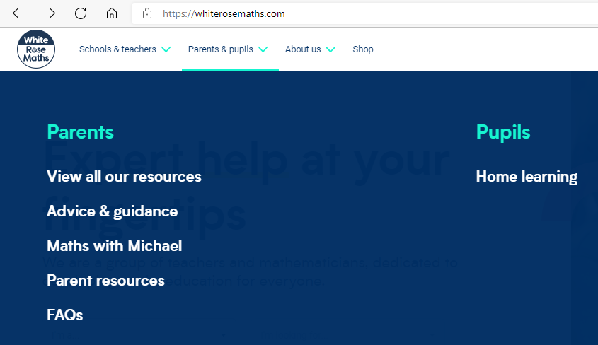
3. In the search bar select Early years for the year group and Autumn for the term and then click filter. You will the see a list of topics. Next click on view more on the Light and Dark tab.
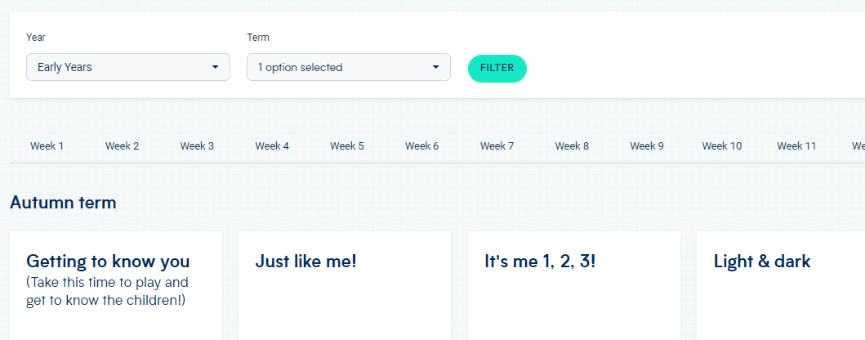
4. Scroll down the page until you find the final video – its week 3 session 5 (or video 15). Watch the video and complete the activity and then upload a photo of your completed work. Thank you
