Thursday 16th December Phonics Activity

Practise reading and writing the following tricky words.

Challenge 1
Write a sentence for each tricky word.
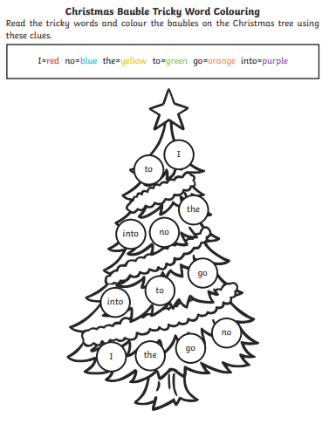
Challenge 2

