Wednesday 24th February 2021.
CM
CM
Learning Objective: Can I read and use a ruler accurately? CM
CM
CM
CM

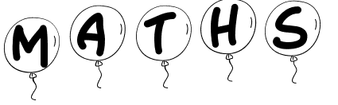
CM

Colour the balloon with the longest string: RED

Colour the balloon with the shortest string: YELLOW

Colour the balloons with the same length: GREEN

