07.01.2021 Electricity Assessment-Year 2 Autumn term-2

Draw or write three items that use electricity

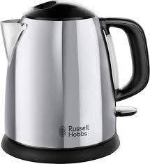
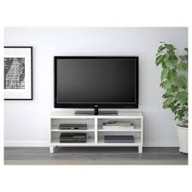
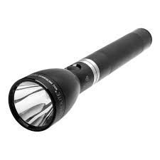
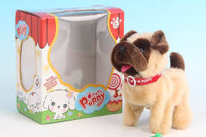
Tick the objects that use batteries only.

Draw a circuit diagram that would light up a bulb

How can you make the bulb brighter?
…………………………………………………………………………………………………
…………………………………………………………………………………………………
What would happen if you had two bulbs and one battery in one circuit?

………………………………………………………………………………………………….
………………………………………………………………………………………………….

Can you think of three things you must remember to keep you safe when using electricity?

1…………………………………………………………………………………………………

2………………………………………………………………………………………………

3………………………………………………………………………………………………

Is there anything else that you have learnt about electricity this half term?

