Group the bananas into 2s.
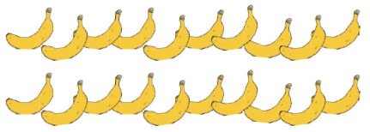
How many groups do I have?_____________

Group the bananas into 5s.
How many groups do I have?______________

Group the bananas into 10s.
How many groups do I have? _________
Group the bananas into 2s.
How many groups? ___________

Group the bananas into 2s
How many groups?_______

Group the birds into 2s.
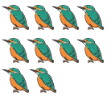
How many groups? _______

Group the birds into 5s.
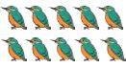
How many groups? __________

Group the pens into 2s.
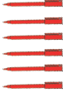
How many groups? __________

