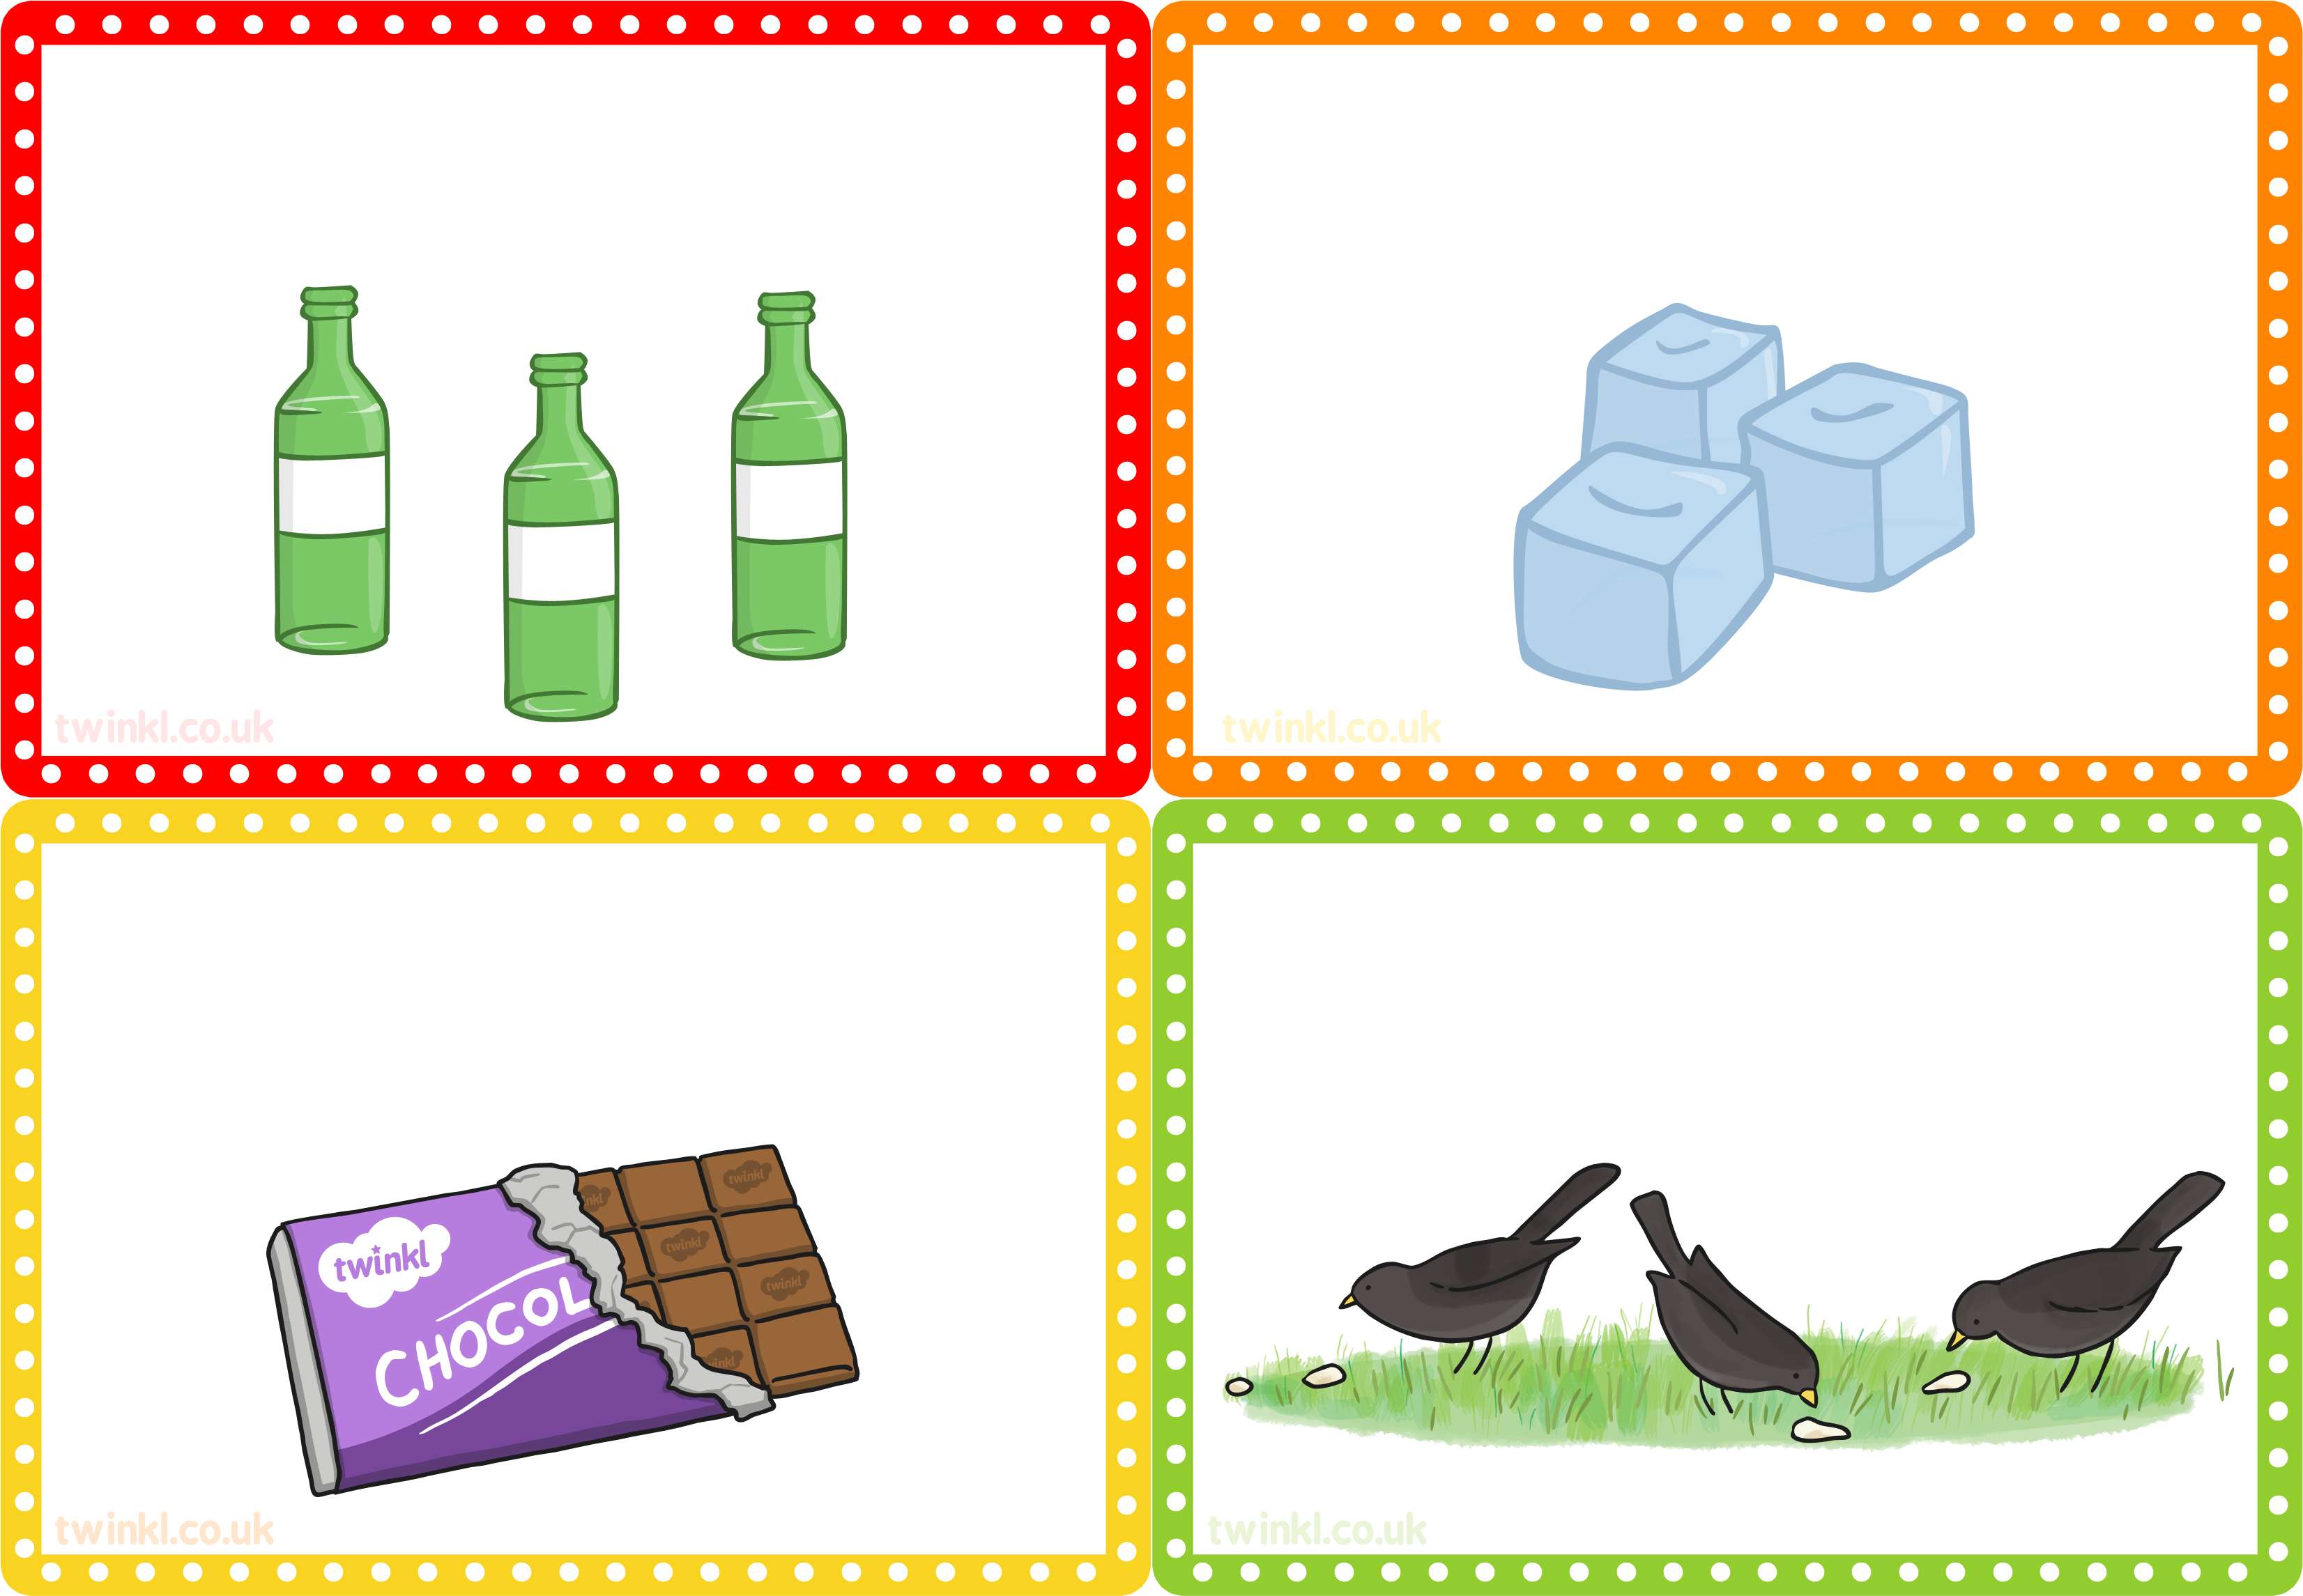
If you had 10 glass bottles and 3 of them smashed, how many of them would you have left?
If you had 5 ice cubes and 2 of them melted, how many would you have left?
If you had 20 squares of chocolate and you ate 15 of them, how many would you have left?
If you had 5 birds in your garden and 1 of them flew away, how many birds would you have left?
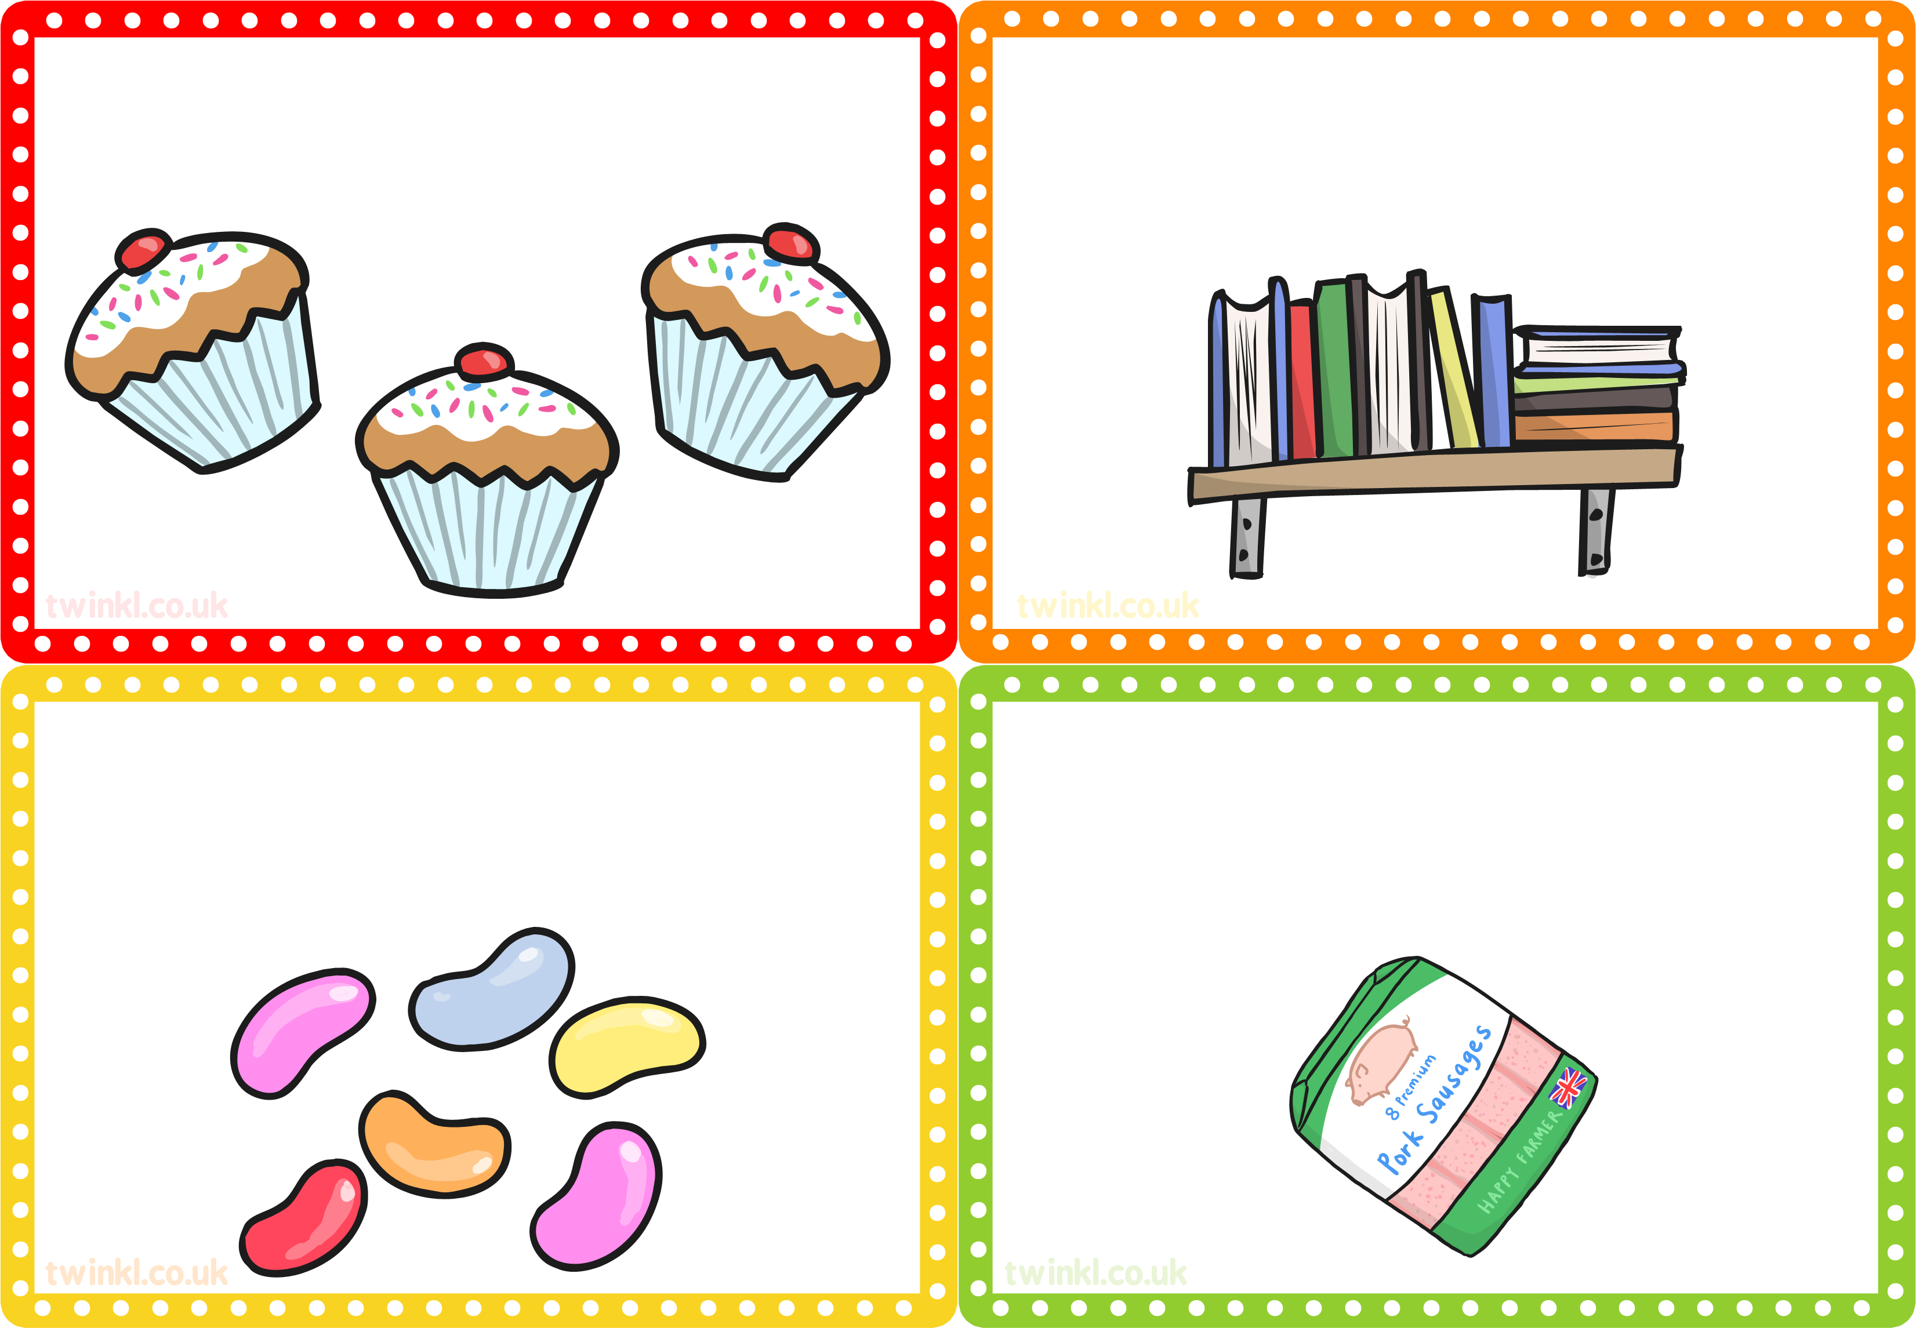
If you had 10 currant buns and 8 of them have been eaten, how many of them would you have left?
If you had 5 books and you have read 3 of them, how many would you have left to read?
If you had 20 jelly beans and you have eaten 6 of them, how many would you have left?
If you had 10 sausages in a pack and you have cooked 4 of them, how many sausages would you have left in the packet?
If you had 10 currant buns and 8 of them have been eaten, how many of them would you have left?
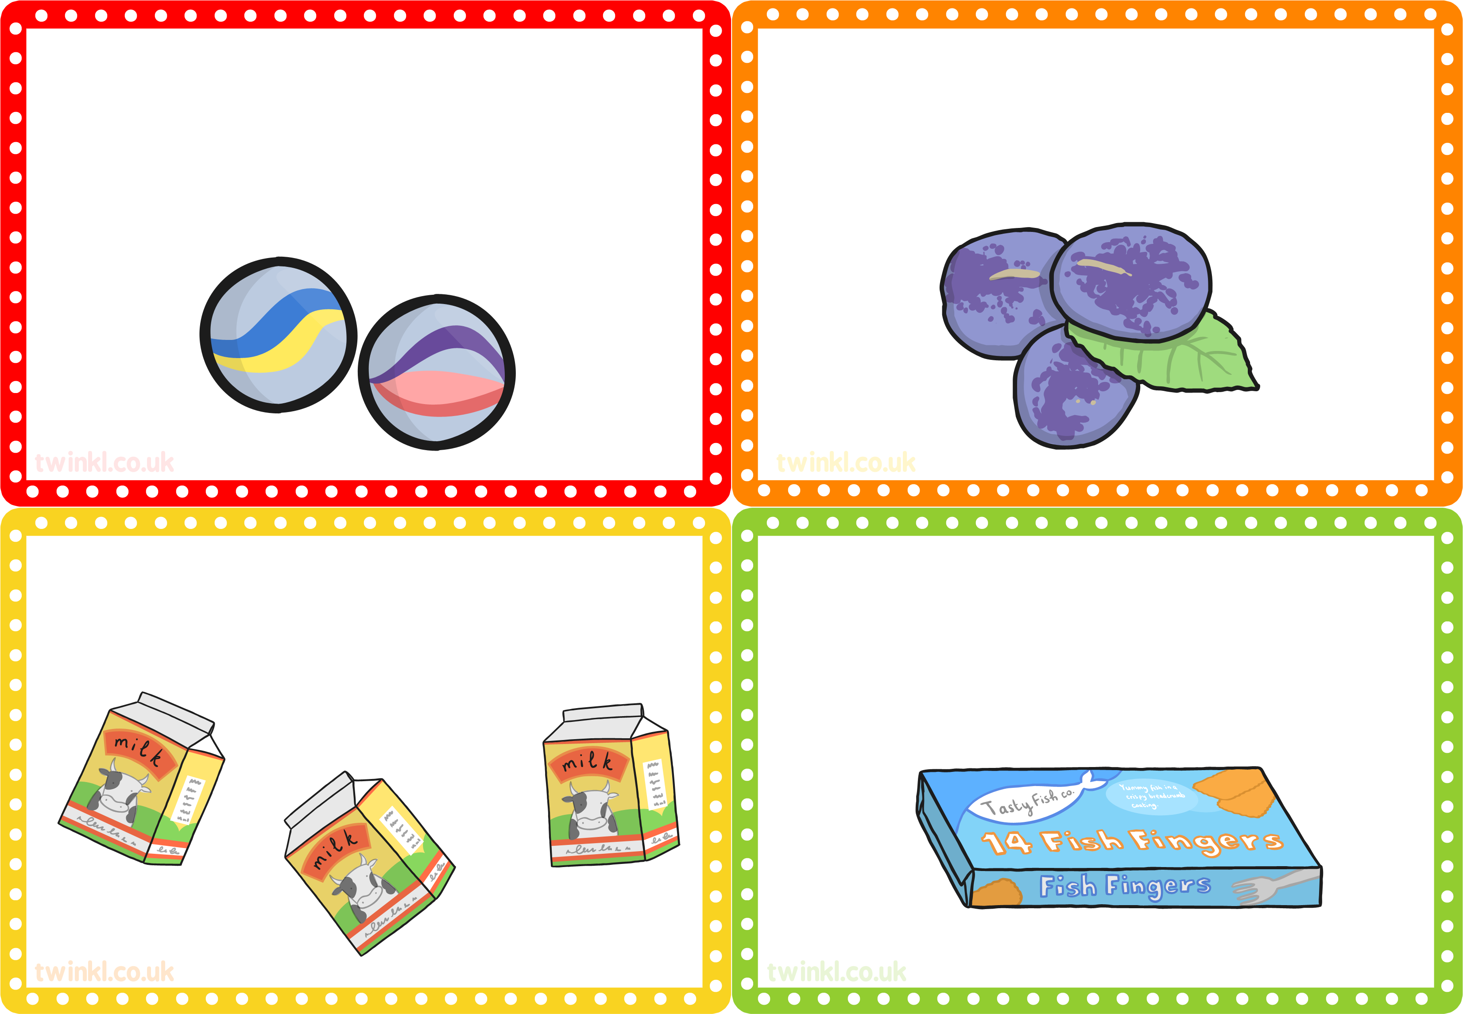
If you had 10 marbles and 2 of them have rolled away, how many of them would you have left?
If you had 20 plums and you use 13 to make jam, how many would you have left?
If you had 5 fish fingers in a box and you cooked 4 of them, how many fish fingers would you have left in the box?
If you had 20 milk cartons and drink 2 of them, how many would you have left?

