[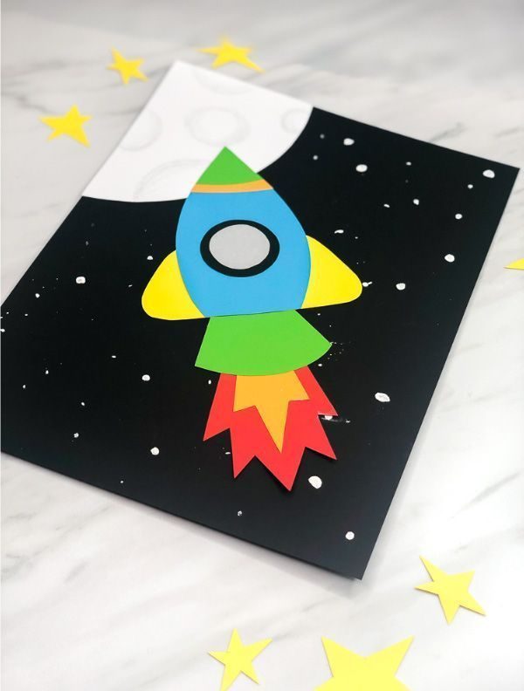](https://www.google.com/url?sa=i&url=https%3A%2F%2Fwww.pinterest.com%2Fpin%2F559290847473802591%2F&psig=AOvVaw0fl3udIPeeMjv8wpPMqJRh&ust=1607593224305000&source=images&cd=vfe&ved=0CAIQjRxqFwoTCIjj_KXOwO0CFQAAAAAdAAAAABAD)