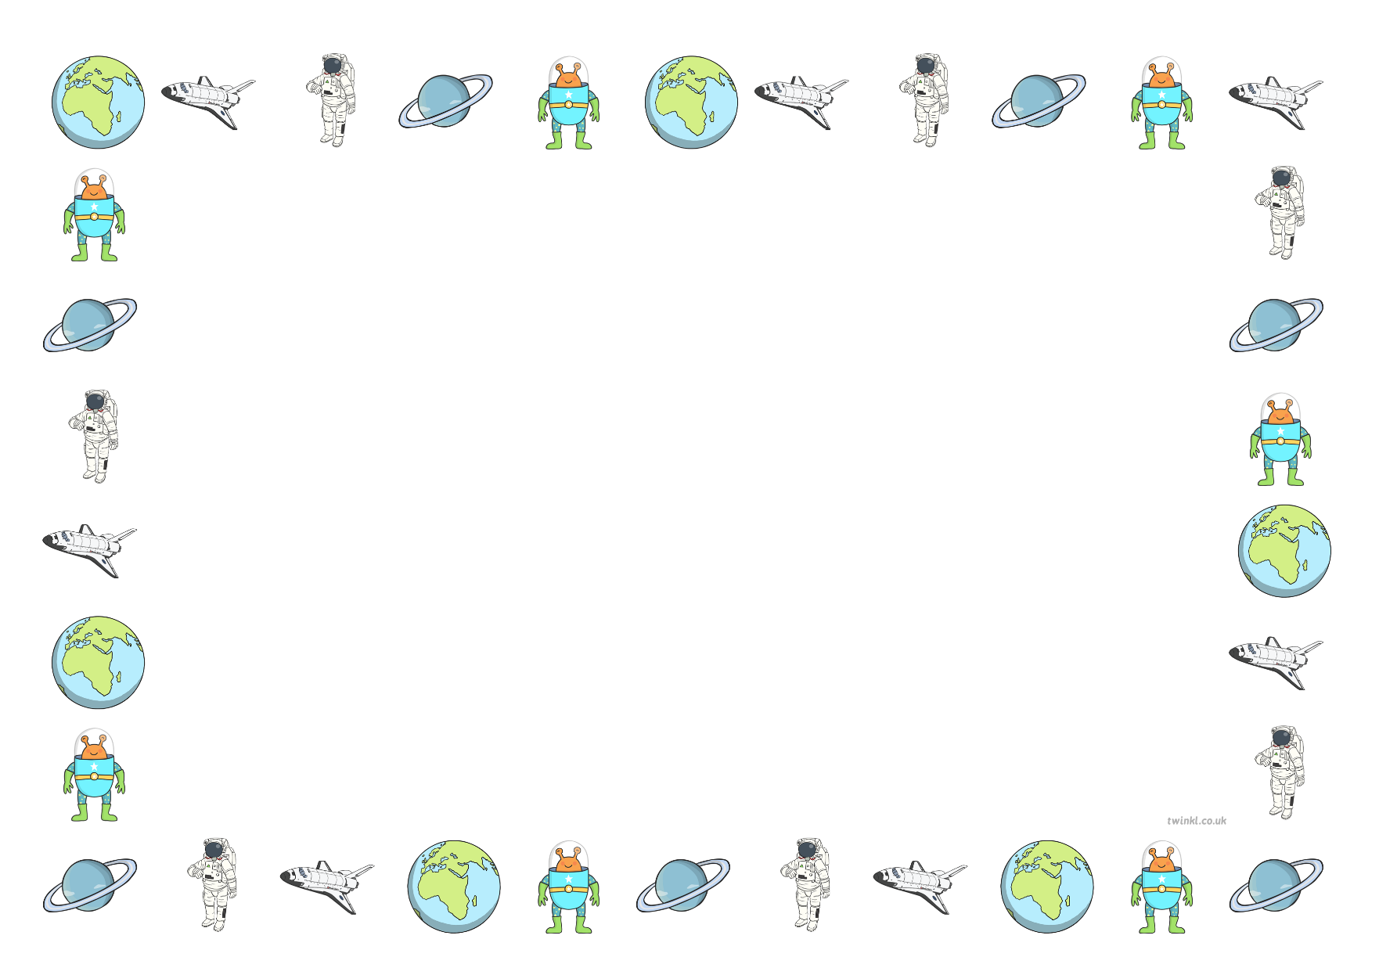
16.12.2020 Design and Technology Focus
Can I evaluate my product?
What went well...

What I found tricky…
I have learnt

