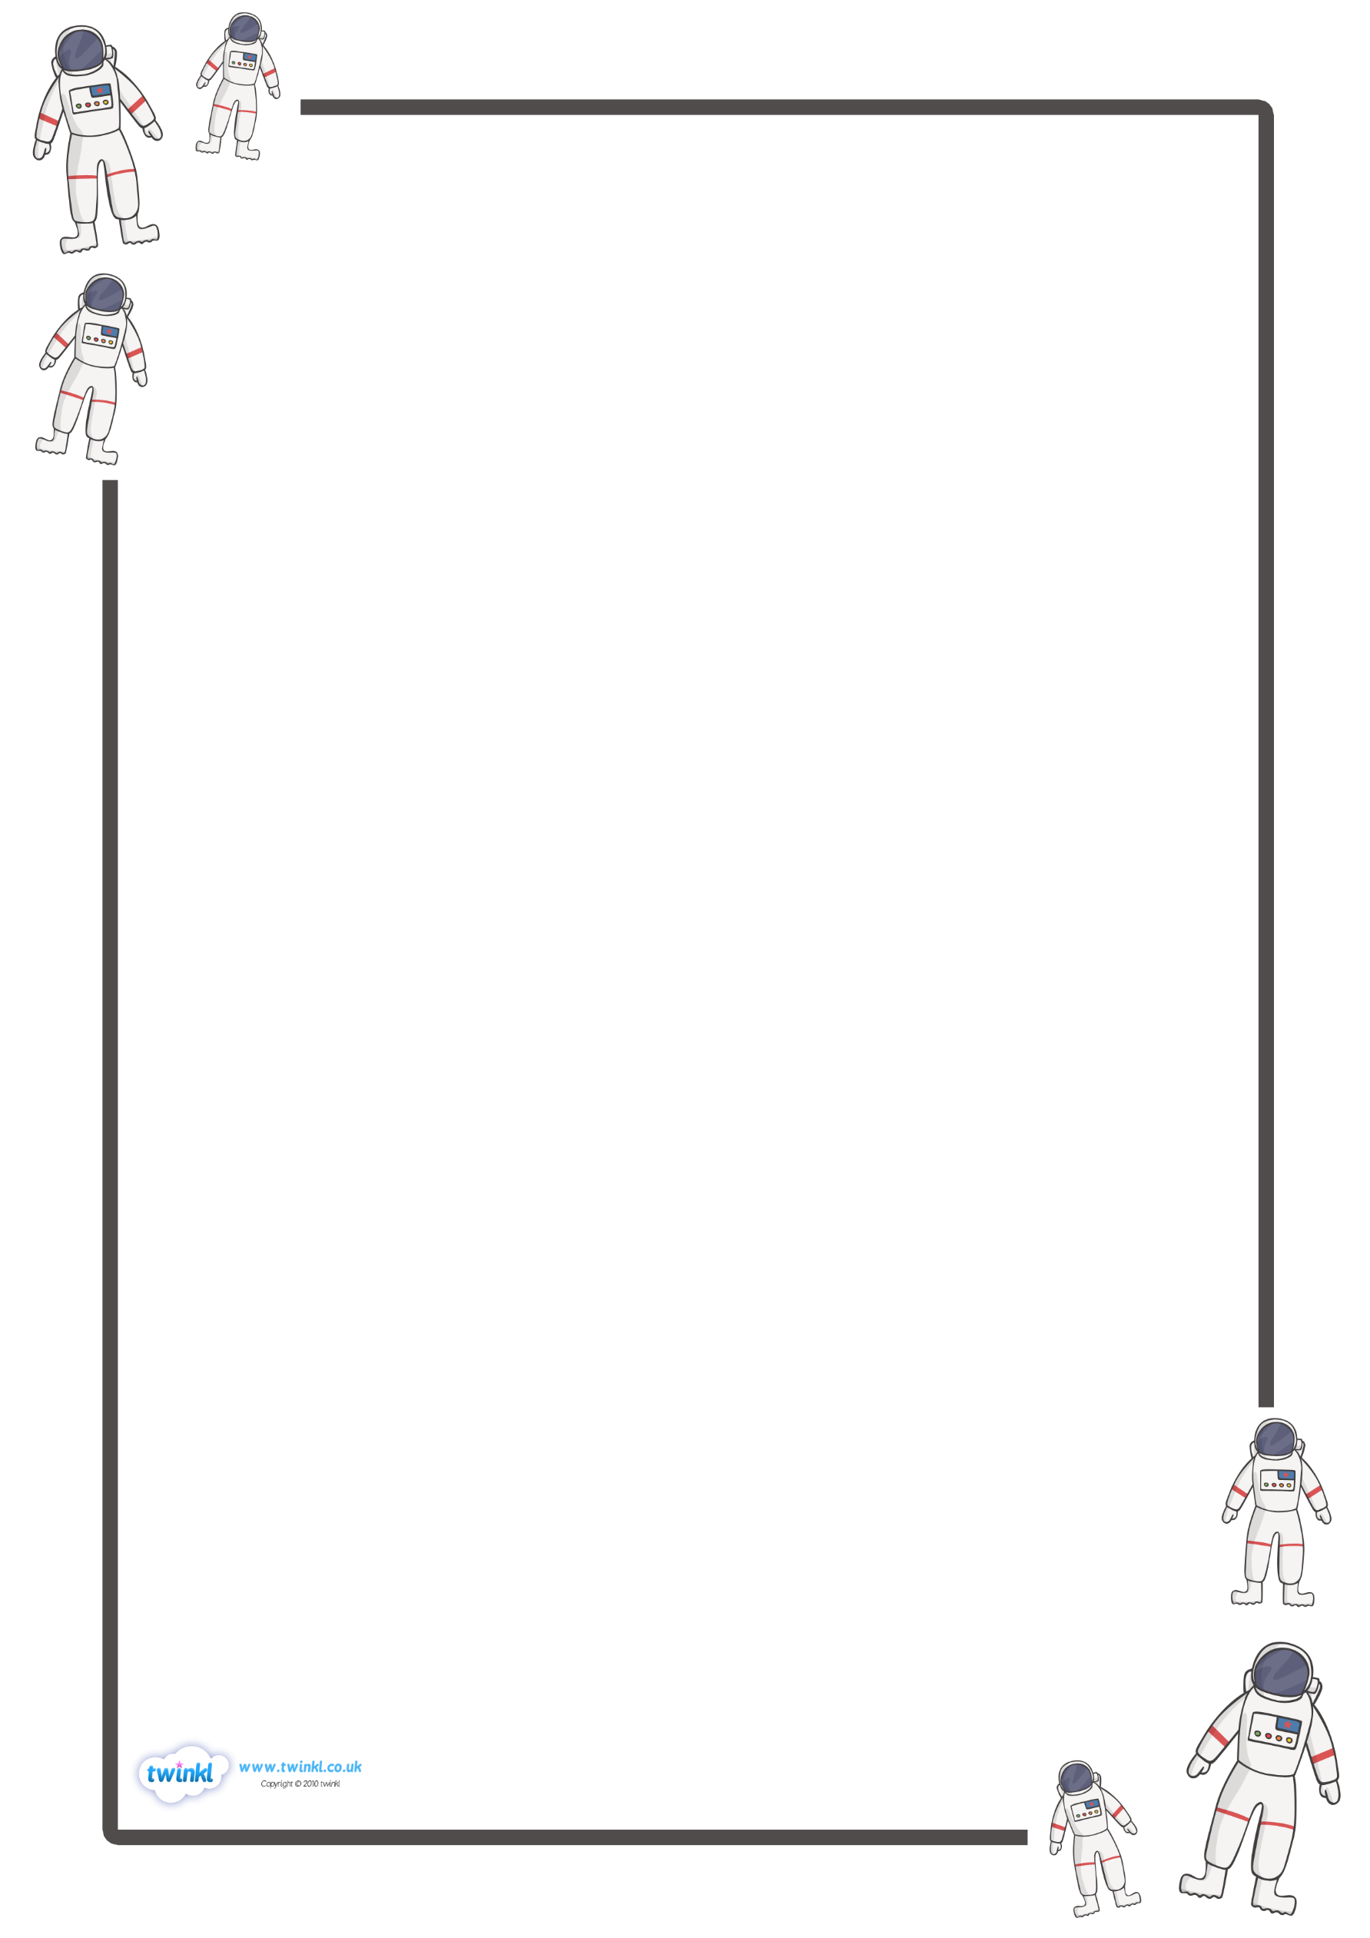
When was Neil Armstrong born?

________________________________________________________________________________________
When did Neil Armstrong die?

__________________________________________________________________________

Which 2 other astronauts were involved in the Apollo 11 mission?

- _____________________________________

- _____________________________________
When did Neil Armstrong and Buzz Aldrin land on the moon?

__________________________________________________________________________
What was special about the moon landing?

___________________________________________________________________________

Can you think of an interesting fact about Neil Armstrong?

23.02.2022 History Focus
Can I answer questions about Neil Armstrong?

