`



**Computing – Graphs**

Pictogram: where a picture indicates a number of objects

Bar chart/ histogram: number indicate by a bar or block

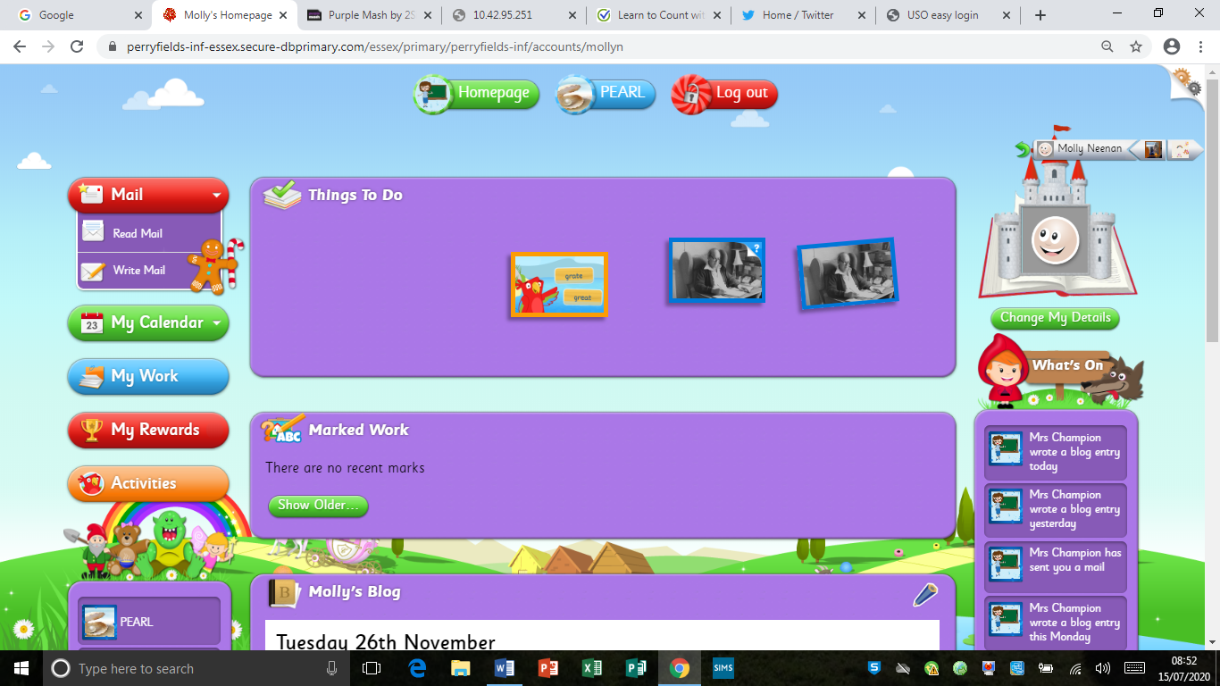

**Word and Keyboard Skills**

Adding capitals - shift, adding spaces – space bar, new lines – enter/ return, changing size, font and colour – command bar

**E-safety**

* Tell and adult if something upsets you.
* Keep personal information and passwords secure.
* Don’t reply to strangers or click links.

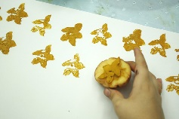

**Design and Technology: textiles**

**Types of stitch:** blanket stitch used for joining pieces, running stitch used for tacking, cross stitch used for decorating

**Embellish:** apply decoration

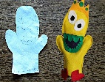

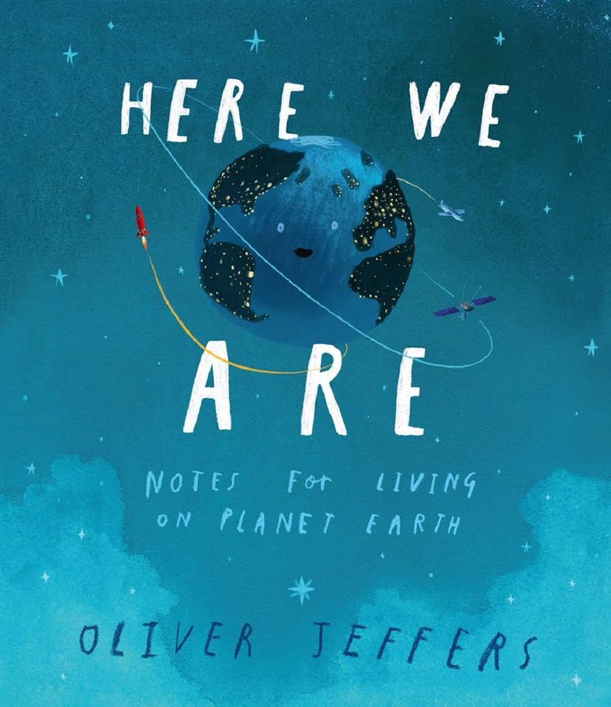

**Focus author: Oliver Jeffers**

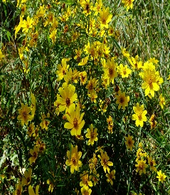

**Science – Plants**

Leaves use the light of the sun and water to make energy

Stems support the plant.

Roots anchor the plant in the soil and take up water.

Flowers attract insects to pollinate then. They are where the seeds form.

Evergreen: a plant that keeps its leaves in winter.

Deciduous: a plant that loses its leaves in winter

**The Human Body**

Skeleton: support the body and protect the organs

Heart: pumps blood round the body

Lungs: take in oxygen

Brain: controls essential organs, thoughts and memory

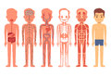

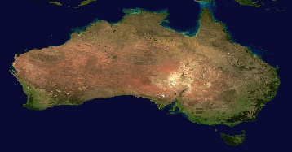 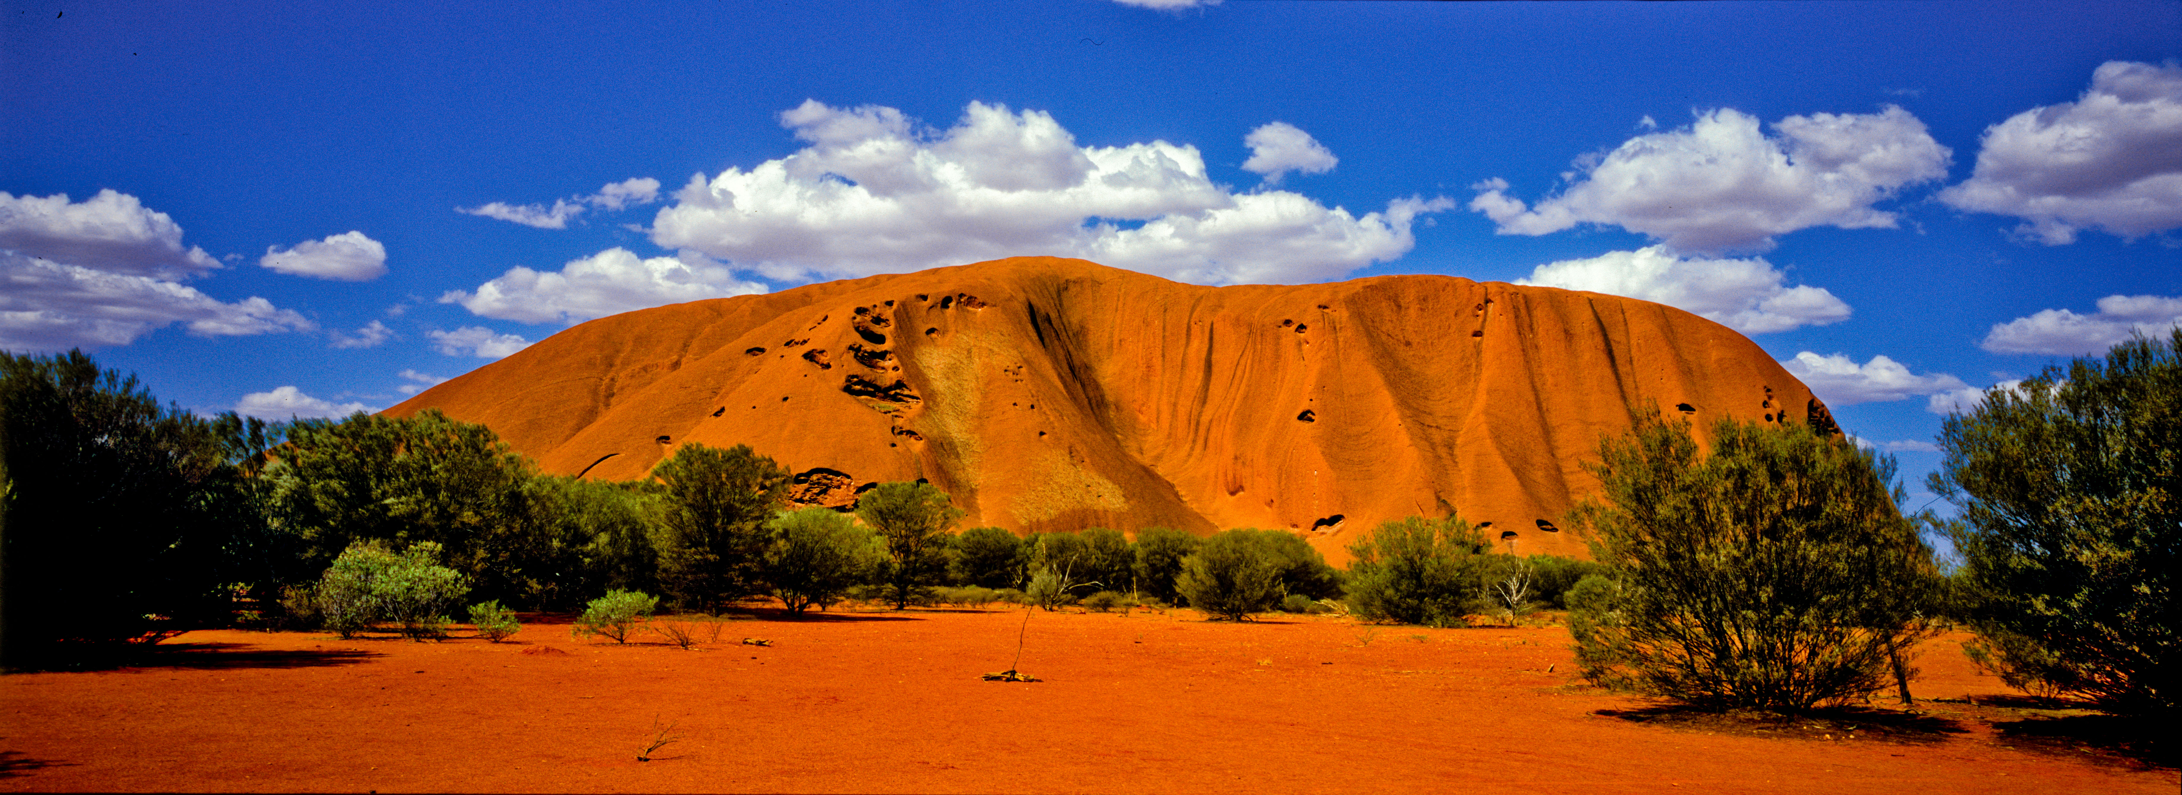 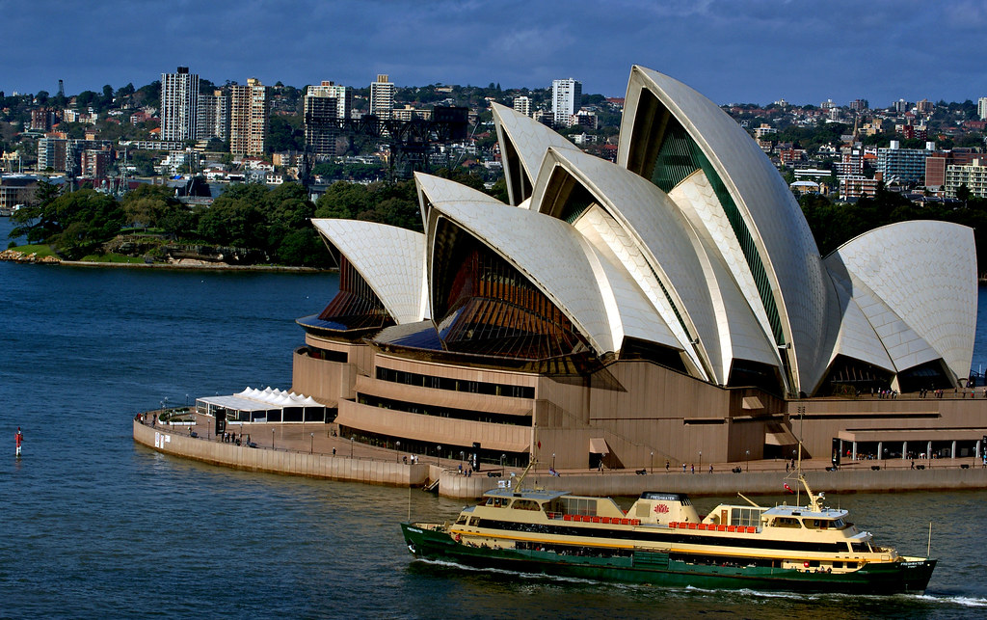

**Geography – a contrasting locality: Australia**

**Capital:** Canberra

**Population:** over 25 million

**Area:** over 7,500,000 square kilometres, similar to USA

90% of Australians live near the coast

**Oceans:** It is surrounded by the Indian and Pacific Oceans

**Organisation:** It comprises 6 states and 2 territories**.**

**Geographical features:** Great Barrier Reef, Uluru, Sydney Harbour

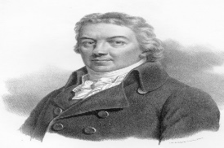 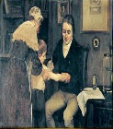

**History – A Prominent Person from the Past**

**Edward Jenner**

Edward Jenner lived 1749-1823

He was credited with introducing the first smallpox vaccine.

He lived his whole life in the Georgian time.

At the time, people had big families and many children died young.

Other events: American Independence, French Revolution, industrial revolution.

Another famous scientist from the time: **Mary Anning**. She discovered dinosaur fossils in Dorset.

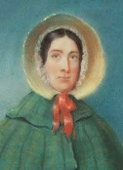

**Art: printing**

**Vegetable cut:** shapes cut out of a vegetable to leave a shape

**Press print**: shapes pressed into a soft material to leave an area that will not print.

**Here We Are**

**Knowledge Organiser - Year 1**