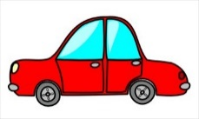
There are 3 cars in the car park. Each car has 3 people in. How many people are there altogether?
There are 6 cats in the tree. Each cat has 2 ears.
How many ears are there altogether?
There are 7 dogs on the bench. Each dog has 3 bones.
How many bones are there altogether?
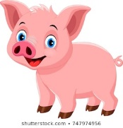
There are 5 pigs in the mud. Each pig has 4 apples.
How many apples are there altogether?

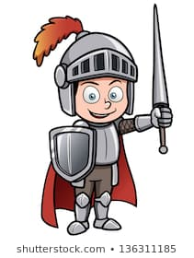
6 knights had 3 swords each. How many swords did
they have altogether?

