went
and
on
mum
it
dad
can
is
get
in
I
go
you
was
the
we
my
no
said
to
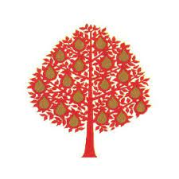

Foundation Stage High Frequency Words
Spelling Certificate Award

