18.1.21 Can I plan a new story?
Who will your baby animal be? It could still be the owl, or another animal that nests in a high place, such as a heron, a squirrel or a monkey.

My baby animal will be: a squirrel………….

Draw a picture of the mother animal and identify the 3 features that the baby describes – this could be size, colour, size or shape of ears, teeth/beak shape, claws/feet, feathers/fur, etc.
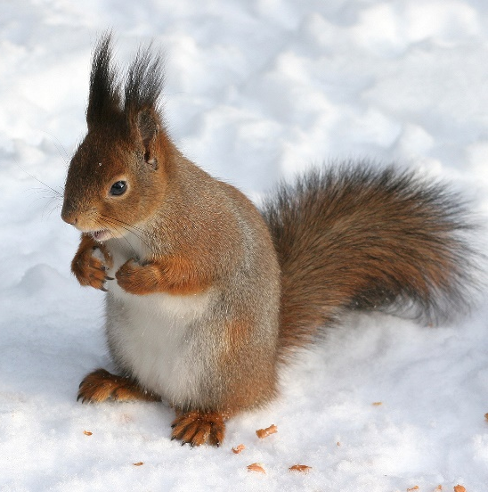
Feature 1: a bushy tail………………….

Feature 2: tufty ears………………………….

Feature 3: long whiskers……………………….

The other animals
Another animal with feature 1 Another animal with feature 2 Another animal with feature 3
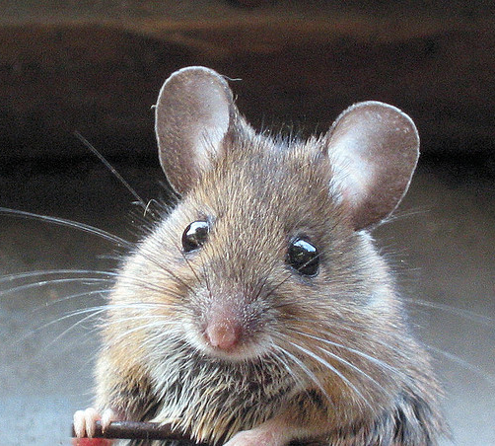
mouse
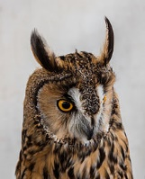
owl
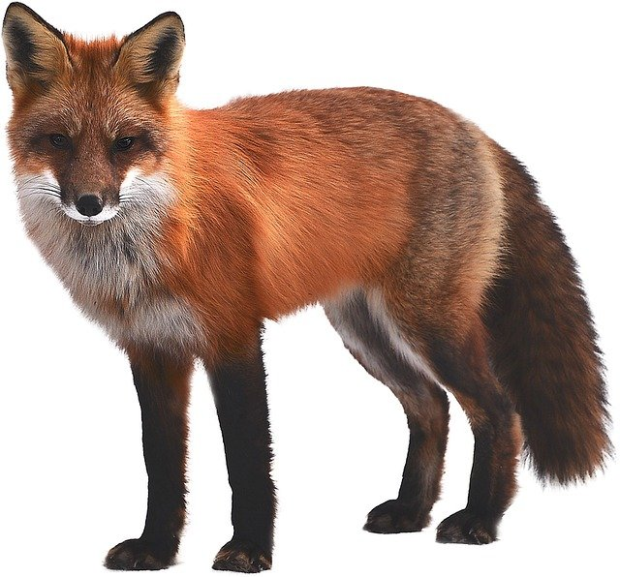
fox

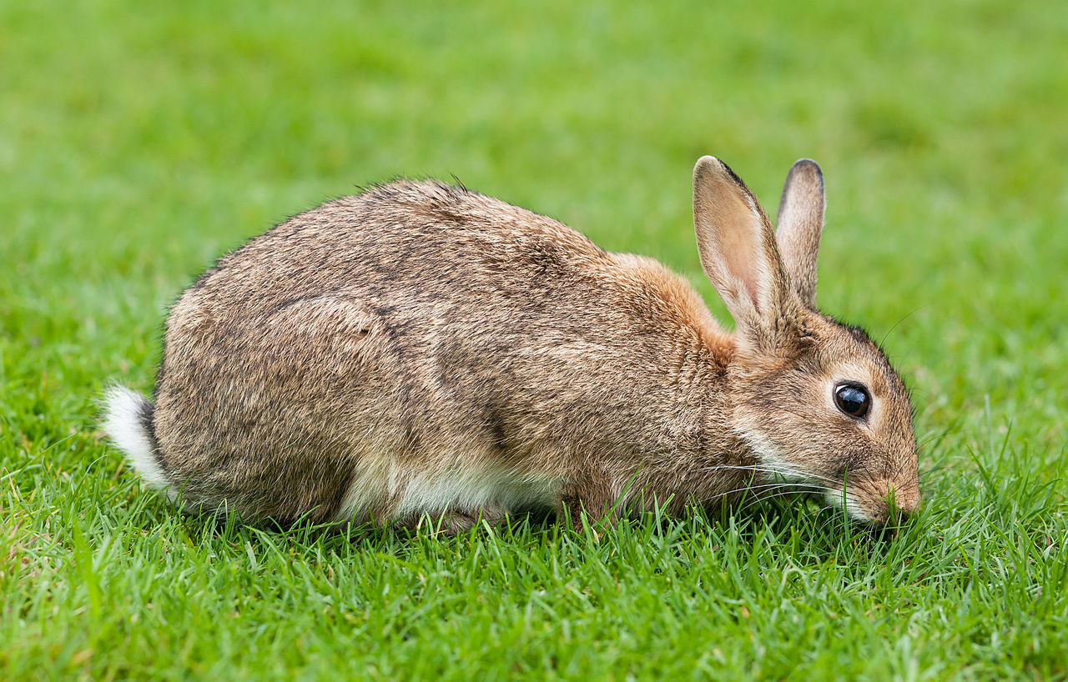
The animal who tries to help the lost baby:
rabbit

