Maths Challenge work for the week
Monday
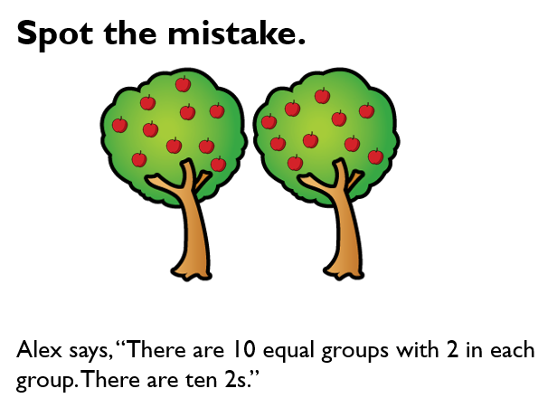

Explain what the mistake is and why…………………………………………………………………………………………………

………………………………………………………………………………………………………………………………………………………….

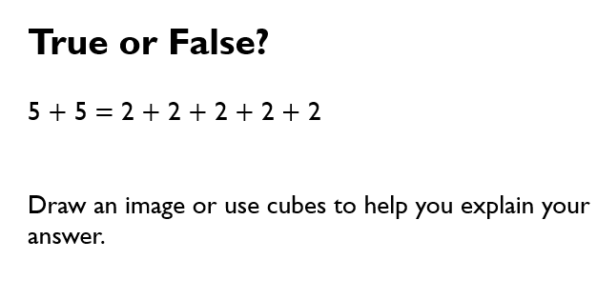
…………………………………………………………………………………………………………………………………………………………..

………………………………………………………………………………………………………………………………………………………..

………………………………………………………………………………………………………………………………………………………..

Maths Challenge work
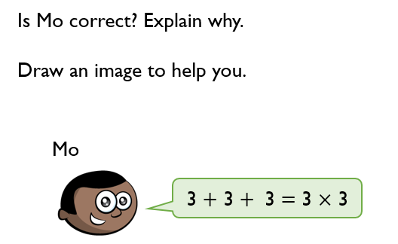
Tuesday

………………………………………………………………………………………………………………………………………………………….

…………………………………………………………………………………………………………………………………………………………

………………………………………………………………………………………………………………………………………………………..

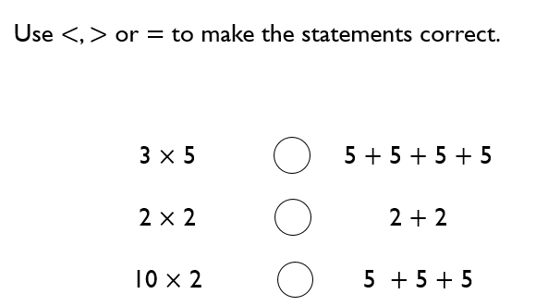

Wednesday
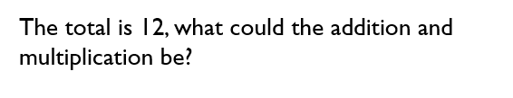

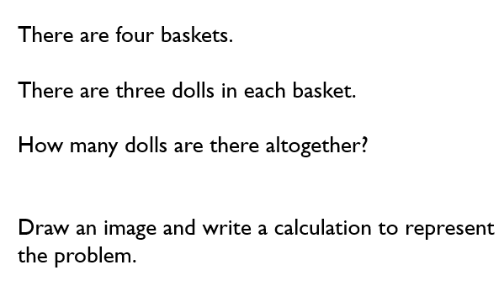

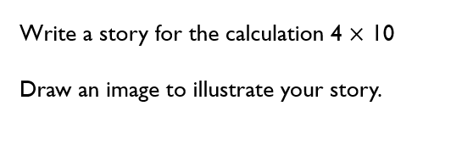
Thursday

Friday








