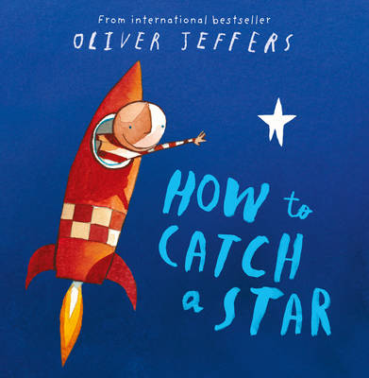[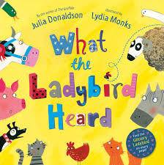](http://www.google.co.uk/imgres?imgurl=http://ecx.images-amazon.com/images/I/91qT3G36cTL._SL1500_.jpg&imgrefurl=http://www.amazon.co.uk/What-Ladybird-Heard-Julia-Donaldson/dp/0230706509&h=1500&w=1490&tbnid=6K6ZLizQ5am5-M:&zoom=1&q=what%20the%20ladybird%20heard&docid=QRYGZlNVfn9rWM&ei=Rc8RVPz3F4fnaOPOgPgO&tbm=isch&ved=0CCMQMygCMAI&iact=rc&uact=3&dur=498&page=1&start=0&ndsp=16)C:\Users\Teacher\AppData\Local\Microsoft\Windows\Temporary Internet Files\Content.IE5\7I7HHP6B\MC900281179[1].wmf[](http://www.google.co.uk/imgres?imgurl=https://coderwall-assets-0.s3.amazonaws.com/uploads/picture/file/651/colorful_stripes_by_timpietrusky.png&imgrefurl=https://coderwall.com/p/4okplg&h=233&w=985&tbnid=nDuKToNSq5o_vM:&zoom=1&q=stripes&docid=FvHnypXVPddYOM&ei=3s8RVIS-Ic3-aO25gPgO&tbm=isch&ved=0CC4QMygNMA0&iact=rc&uact=3&dur=2395&page=1&start=0&ndsp=17)[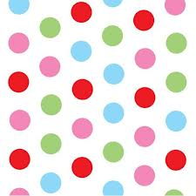](http://www.google.co.uk/imgres?imgurl=http://dotsandspots.co.uk/138-181-large/multi-spots-gift-tag.jpg&imgrefurl=http://dotsandspots.co.uk/138-multi-spots-gift-tag.html&h=600&w=600&tbnid=UZAsIshb2_lvEM:&zoom=1&q=spots&docid=nodu0TZmKdHu4M&ei=RNARVM3SE8ndaPKkgvAO&tbm=isch&ved=0CCYQMygFMAU&iact=rc&uact=3&dur=520&page=1&start=0&ndsp=21)[](http://www.google.co.uk/imgres?imgurl=https://coderwall-assets-0.s3.amazonaws.com/uploads/picture/file/651/colorful_stripes_by_timpietrusky.png&imgrefurl=https://coderwall.com/p/4okplg&h=233&w=985&tbnid=nDuKToNSq5o_vM:&zoom=1&q=stripes&docid=FvHnypXVPddYOM&ei=3s8RVIS-Ic3-aO25gPgO&tbm=isch&ved=0CC4QMygNMA0&iact=rc&uact=3&dur=2395&page=1&start=0&ndsp=17)Name 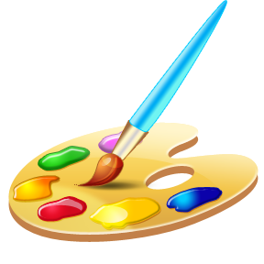

**In Literacy**

Name writing

Letters and sounds

Alphabet song

Labelling

Writing lists

Story maps

Sentence writing

**We will make…**

Biscuits

Monsters and aliens!

Paintings

Collages

**In understanding the world**

Programming beebots

Cooking

Using a mouse and keyboard

Homes around the world

Using iPads

**Our focus book is…**

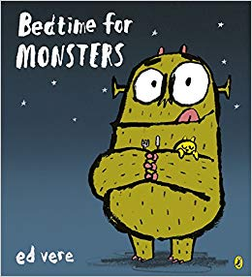

schools.org

**In Maths**

Counting

2D shapes

Positional language

Symmetry

Ordering and sorting

Counting rhymes

Matching numbers and amounts

**Topaz and Ruby Classes theme this term is…**

**Monsters and Aliens!**

**We will be learning all about…**

**Our author focus is…**

**Oliver Jeffers**