**My beach hut would be…**

[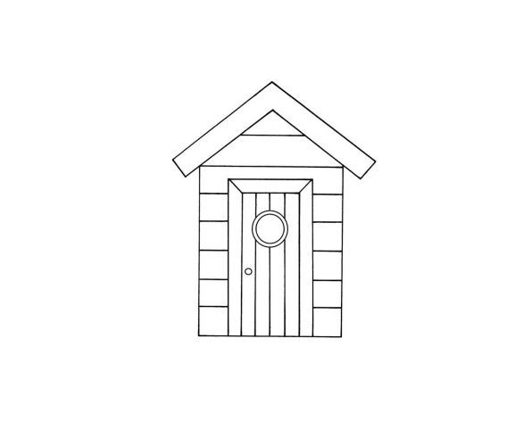](https://www.google.com/url?sa=i&url=https%3A%2F%2Fwww.pinterest.co.uk%2Fpin%2F304907837254955229%2F&psig=AOvVaw1O41vD7u8ALhJHSk4DzZlN&ust=1594469673337000&source=images&cd=vfe&ved=0CAIQjRxqFwoTCKih95bVwuoCFQAAAAAdAAAAABAD)