Wednesday- Circuits and Symbols

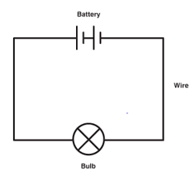
A circuit

Symbols used in a circuit

