Frozen Suncatcher
If you like the idea of making a frozen suncatcher you will need to collect natural materials (e.g. berries, leaves, twigs) from your garden or during a walk.
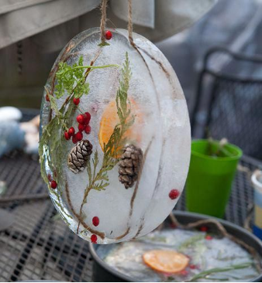
You will need:
A plastic bowl (any bowl if you don’t have a plastic one), some string and some things collected from outside – leaves, twigs, acorns, anything that catches your attention!
What to do:
- Pour water into the bowl and then add the things you have collected from outside, making sure they are covered in the water.
- Put the string inside the bowl too and then put the bowl into the freezer to freeze. This will take a few hours.

- When frozen, remove the ice from the bowl and use the string to hang it up somewhere outside for everyone to see!

How long did yours take to melt?

