6.1.21 Can I add by counting on along a number line?
Draw a ring round the first number in the number sentence then count on by the second number. Every time you count on, draw a bump to the next number on the line. The number you end on is the answer!
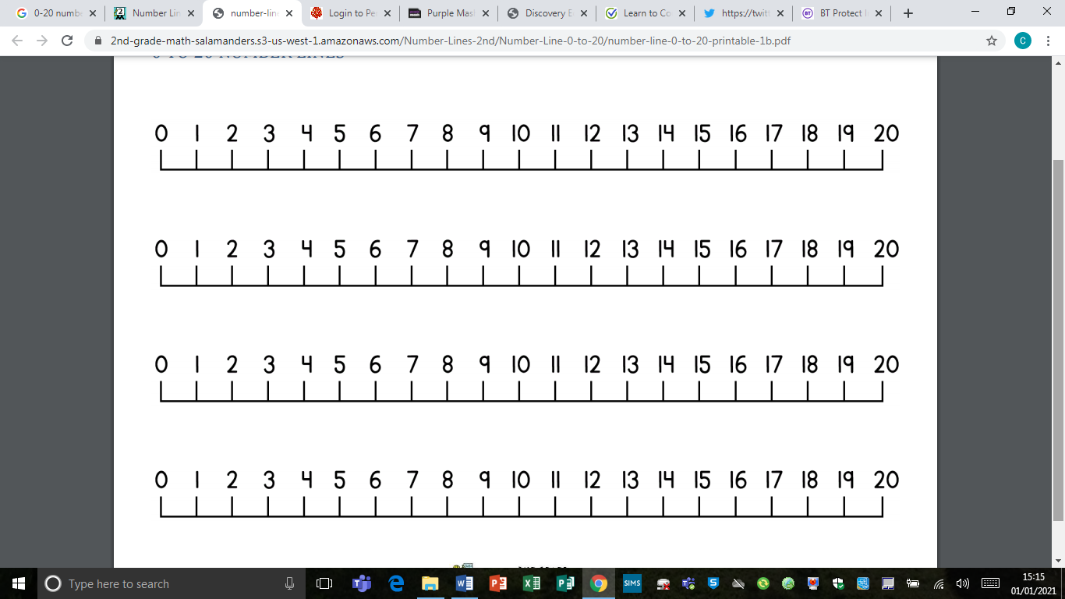
7 + 4 =

9 + 5 =

5 + 4 =

8 + 7 =

11 + 5 =

13 + 4 =

12 + 6 =

14 + 5 =

*Challenge – using a ruler, draw yourself a 0-30 number line. Then make up and solve some more problems where the first number is over 15!

