Cook up a Character
Welcome to the character kitchen, where all story book characters begin their lives. Can you add all of the ingredients to the bowl to make a brand new character to add to a story.
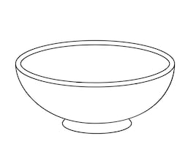
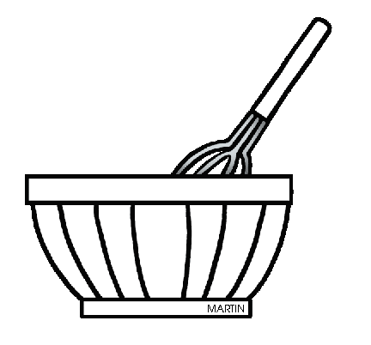
They live _______________________________________________________________________________________________
An interesting fact about them ________________________________________________________________________________________________________________________________
My character wears________________________________________________________________________________________________________________________________________________________________________
My character’s name is _____________________________
Their hair is ___________________________

