Plants
Different types
- There are many different types of plants.
- Some plants have flowers like the daffodil and sunflowers.
- Some plants can be eaten like the potato plant.

Sunflowers growing in a field.
How to look after your plant
- Make sure you water it.
- Make sure you give it plenty of sunlight.

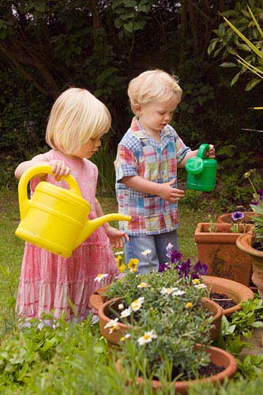
You can use a watering can to water the plants.
Draw a red ring around the title.
Draw a green ring around the heading.
Draw an orange ring around the photographs.
Draw a blue ring around the captions.

