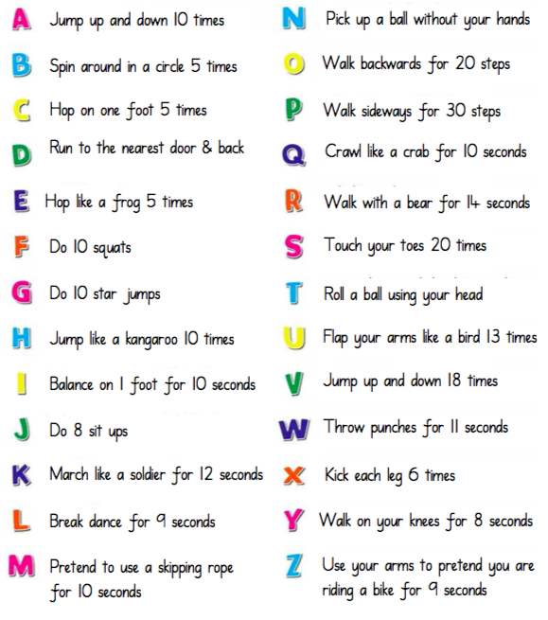
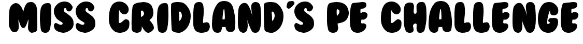
(My example is on the website!)

Choose a word you want to spell.

Find the letters for the word.

Complete the exercises in the correct word order.

Enjoy!

