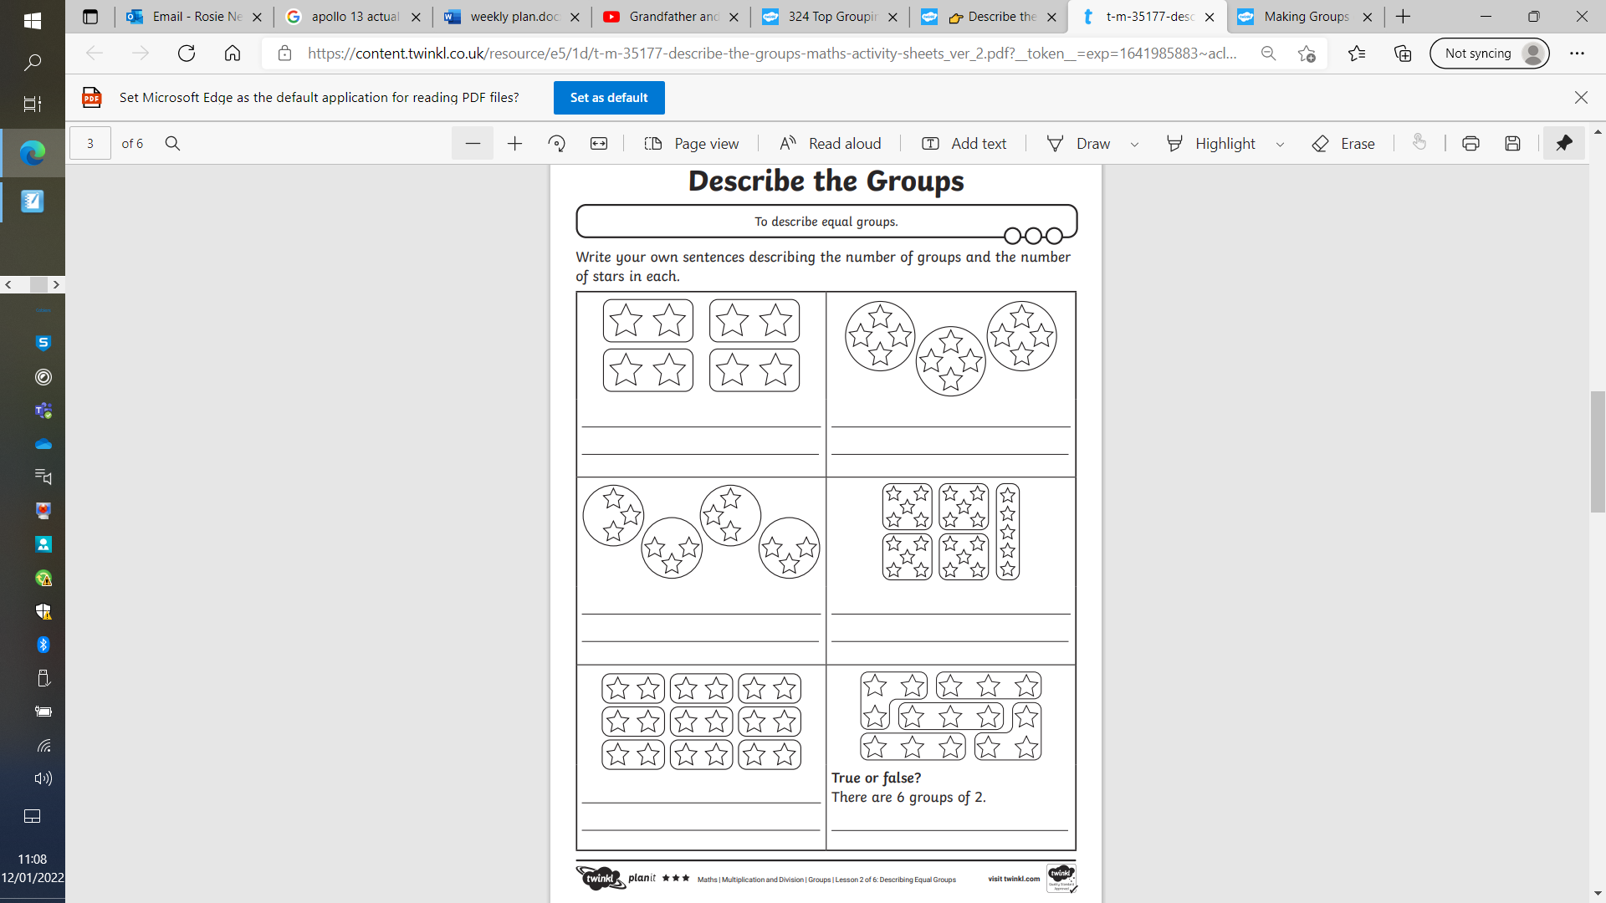

There are 4 groups of 2 stars.

There are 8 stars in total.