|  |  |  |
| --- | --- | --- |
| Living | Not alive | Has never lived |
|  |  |  |

Can I sort different things into groups according to if they are living, not alive or never lived?

**Can you describe the difference between something that is living and something that is not alive?**

……………………………………………………………………………………………………………………………………………………….

………………………………………………………………………………………………………………………………………………………

……………………………………………………………………………………………………………………………………………………

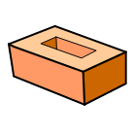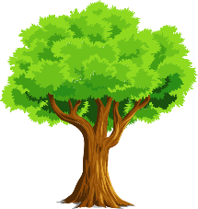apple_col