[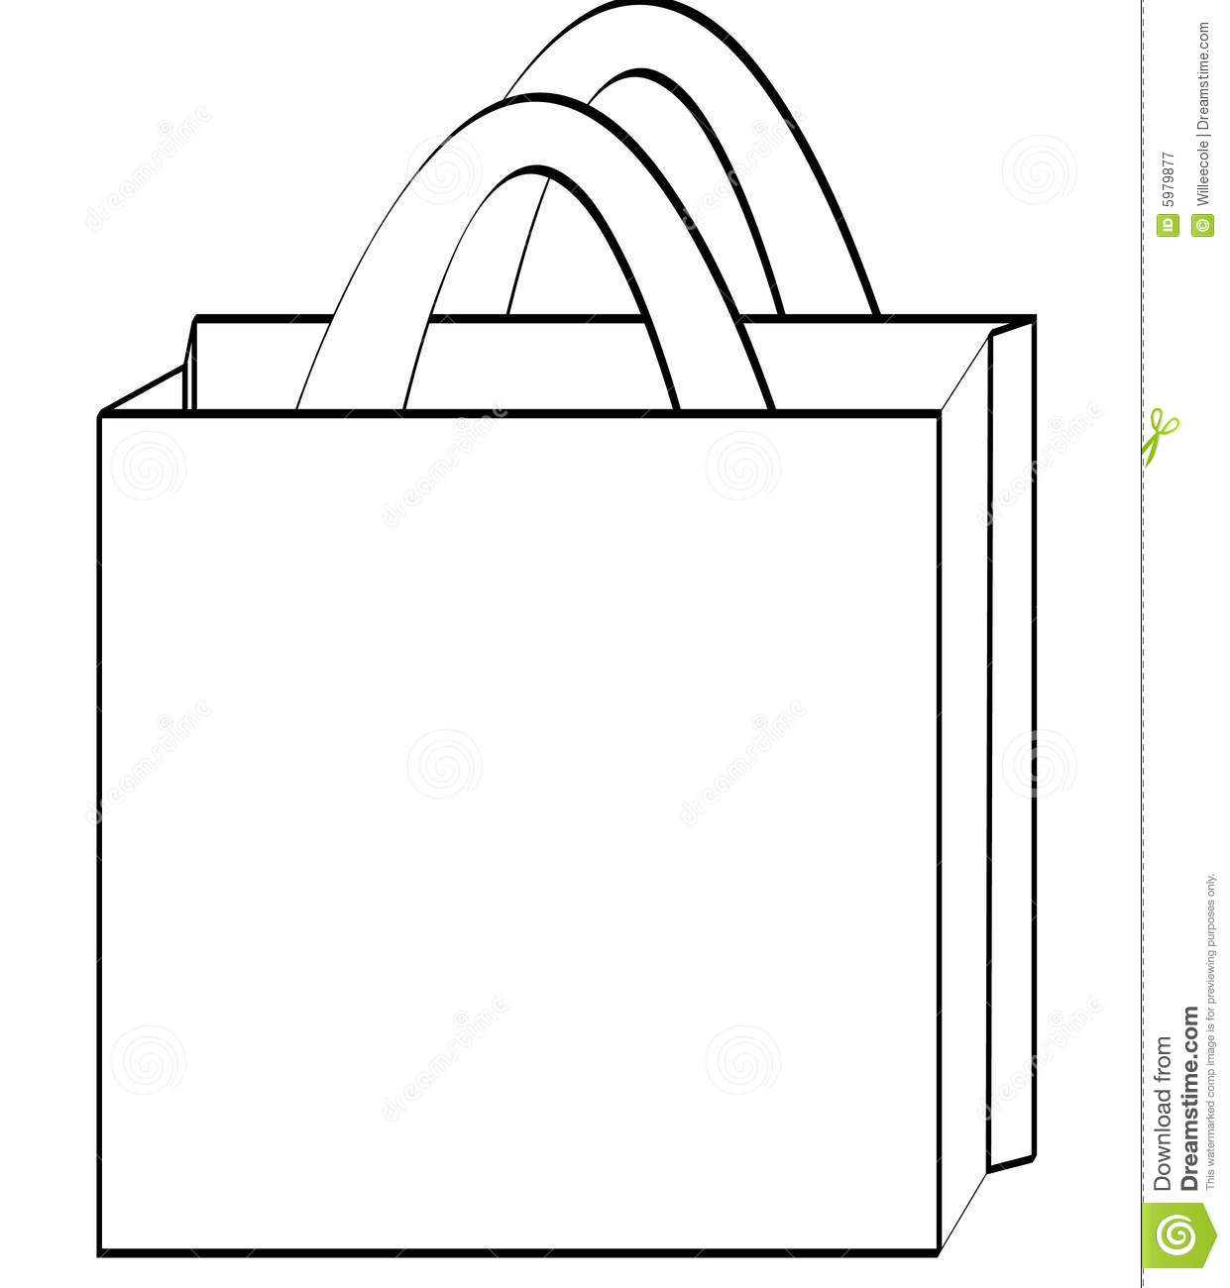](https://www.google.com/url?sa=i&url=https%3A%2F%2Fwww.artofmikemignola.com%2Ffree-shopping-bag-clipart-black-and-white%2F&psig=AOvVaw1SCP3HHV8gW06sTtgCdEwy&ust=1594467480818000&source=images&cd=vfe&ved=0CAIQjRxqFwoTCLjs_4LNwuoCFQAAAAAdAAAAABAJ)

**Staying Safe in the Sun!**