Maths activities – Tuesday 19th January 2021

**Activity 1**

You will need the pegs/ pasta etc. from the previous day for the first activity. The adult should take a handful of the resources and the child should again sort them into groups of 10 to count them. An extension of this activity (which will need more pieces) is to make 2 piles and for the child to count both and say/ use the sign < or > to show which represents the larger number.

**Activity 2**

For the second activity, you will also need the number cards from the previous day. Take a card from the shuffled pack and the child should count out the correct number of pieces, arranging them into groups of 10. They should be able to tell you how many tens are in the number **after** making the total but also begin to recognise the number of tens just by looking at the number. You could have a race to see who can make the given number most quickly!

**When your child has completed *both* the activities above**, they could tackle the questions below.

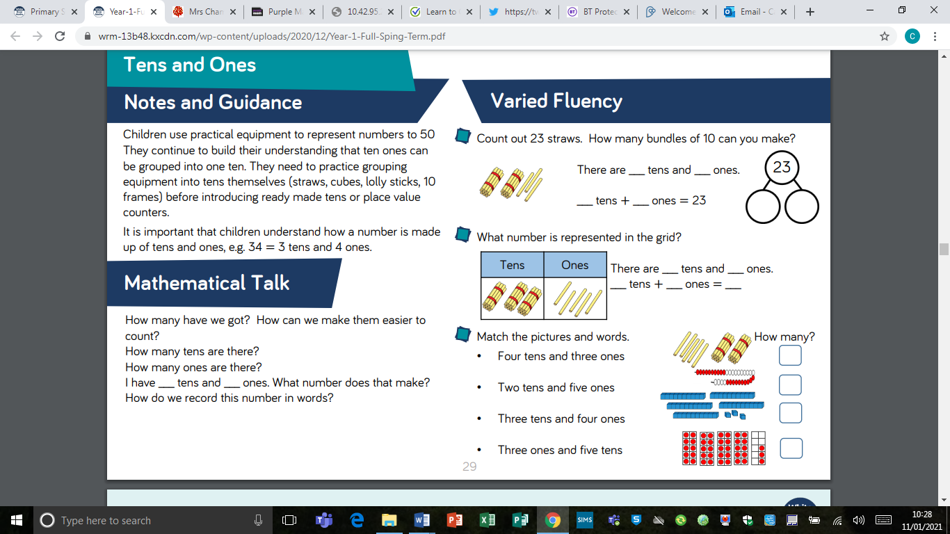





*Challenge: Now drawing a stick/ straight line to represent 10 and a small circle/ dot to represent 1, draw your own pictures to represent these numbers, and write the number:

Four tens and six ones =

One ten and seven ones =

Three tens and two ones =

Two tens and four ones =