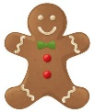`

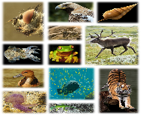

**Science – Animals**

Mammals – have hair and produce milk

Birds – have feathers and lay eggs.

Reptiles – have scaly skin, usually lay eggs.

Amphibians – lay eggs, live part of life in water.

Insects – have an exoskeleton and lay eggs.

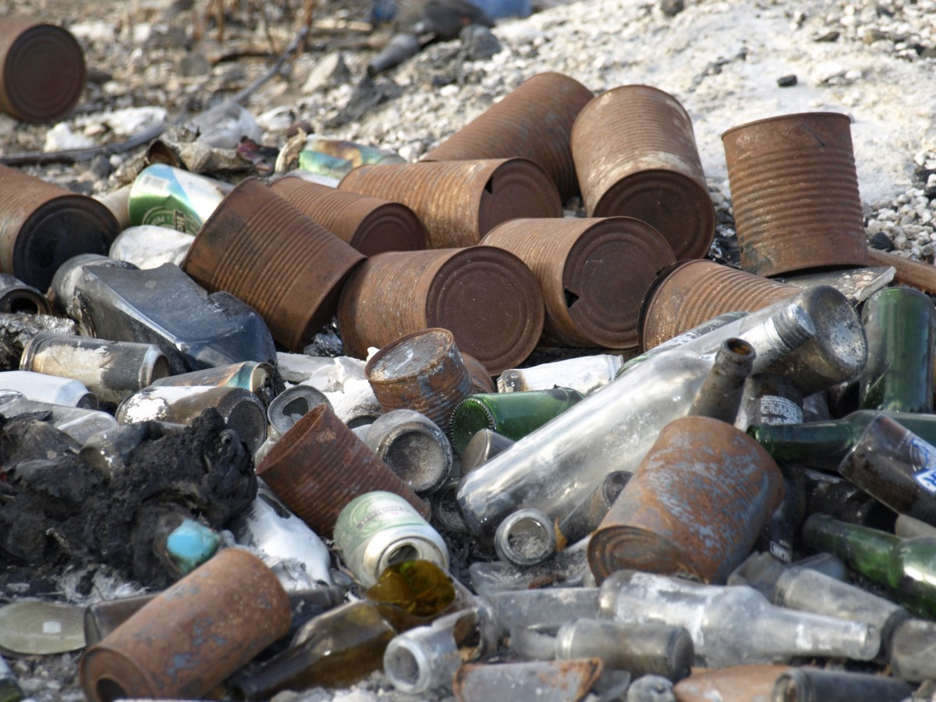 **Materials**

Materials – substances from which objects are made.

Properties – what materials are like/ how they behave.

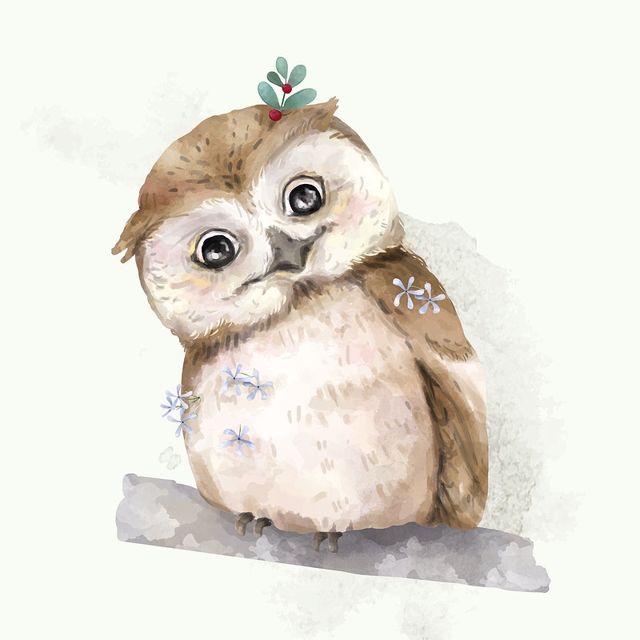

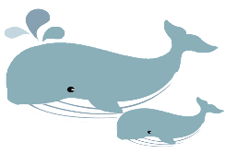

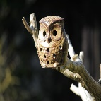

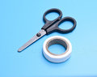

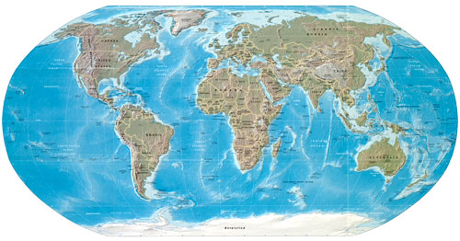

**Geography – continents, oceans and weather**

Continents – Europe, Asia, Africa, North America, South America, Australasia, Antarctica

Oceans – Atlantic, Pacific, Indian, Arctic, Southern

Equator – an imaginary horizontal line passing round the middle of the world.

Poles – the top and bottom of the world, where it is cold.

**Design and Technology: junk modelling (castle)**

Designing a product, learning techniques, applying them, evaluating the finished product.

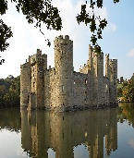

**History – Events beyond living memory**

**Battle of Hastings and castles**

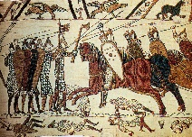

1066 – the year of the Battle of Hastings between the Normans and the Saxons.

King Harold – the Saxon king

Duke William – the Norman duke who invaded and became William the Conqueror

Bayeaux Tapestry – an embroidered picture of the battle.

Castles – built

**Art: sculpture**

**This is 3D art, intended to be viewed from any direction.**

**It can be shaped or marked in many different ways.**

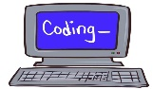

**Computing – Coding**

Algorithm – a clear set of sequenced instructions given to make something happen.

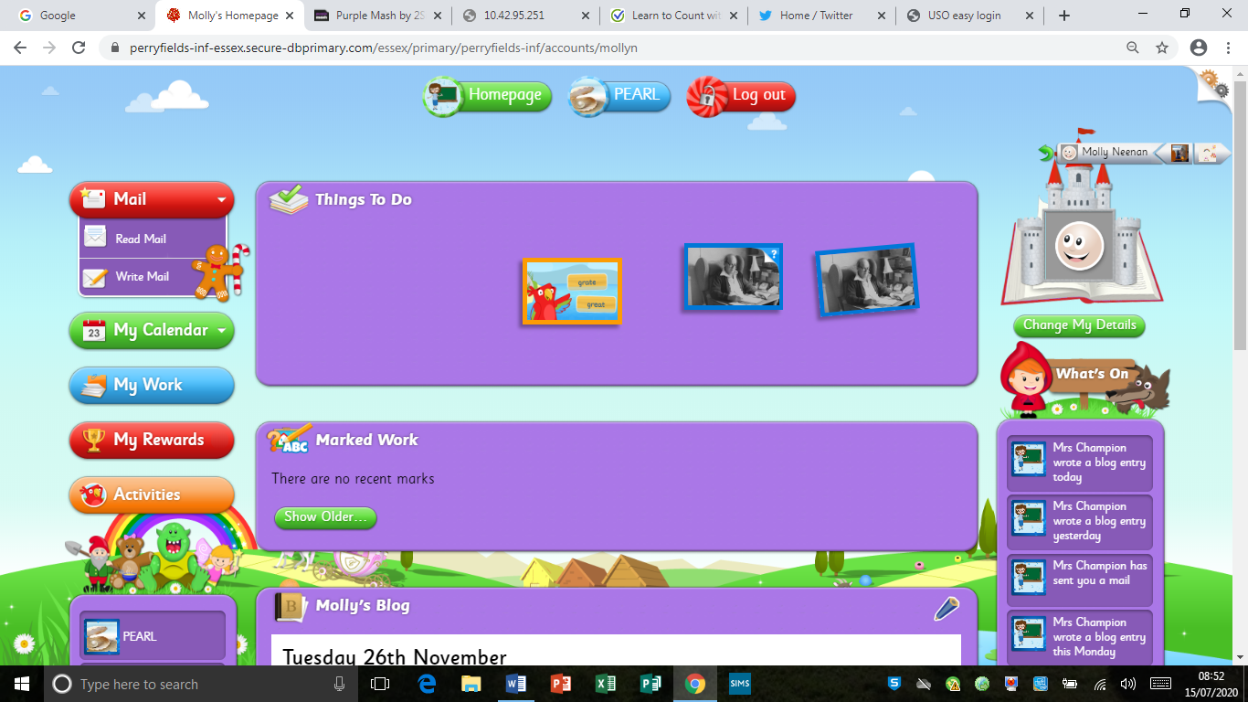 **Internet**

Search engine – a program that searches for items on the World Wide Web using key words.

**e-safety**

Tell and adult if something upsets you. Keep personal information and passwords secure. Don’t reply to strangers or click links.

**Little and Large**

**Knowledge Organiser - Year 1**