Friday 17th December
Phonics Activity
Use your phonics sounds to spell the Christmas CVC words
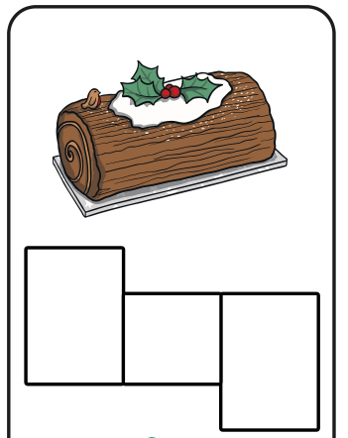
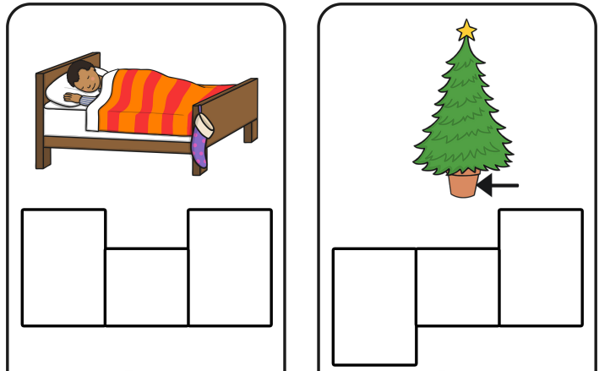
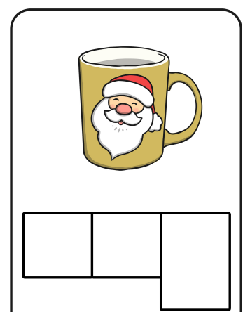
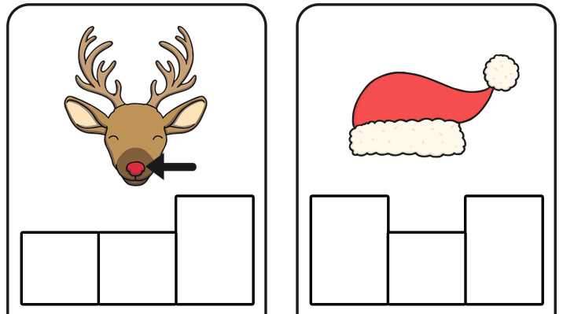

Challenge
Can you write a sentence for each picture? Remember to use finger spaces, capital letters and full stops.

