Kangaroo
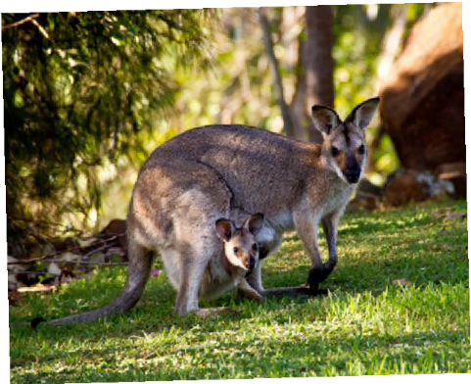

Kangaroos are mammals that are found in every state in Australia.

They are marsupials. This means the baby is kept in a pouch on the mother’s tummy!

The kangaroo has large and powerful hind legs, large feet, a long muscly tail for
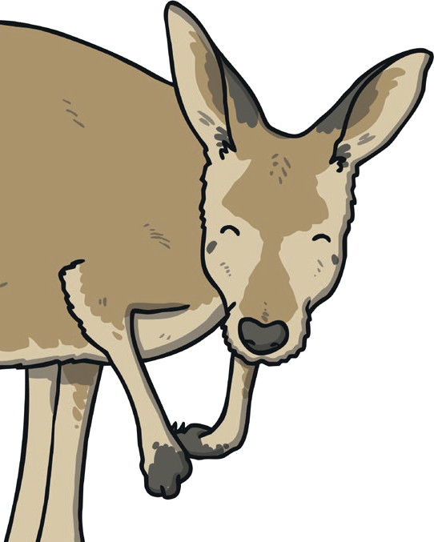
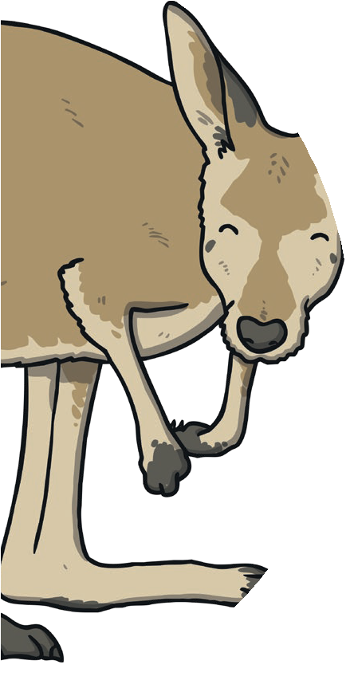
balance and a small head. Male kangaroos can be seen boxing when competing for the attention of a female!
Kangaroos are social animals that live in groups called mobs. They are herbivores so they eat plants, leaves and different grasses.
Kangaroos can reach a weight of 90kg, and can hop at speeds of up to 60km/h.
A male kangaroo is known as a boomer, buck, jack, or old man. The female kangaroo is known as the doe, jill, or flyer. A baby kangaroo is known as a joey. The Red Kangaroo is the largest marsupial
in the world. It can leap as far as 8m and can jump up to 3m high.

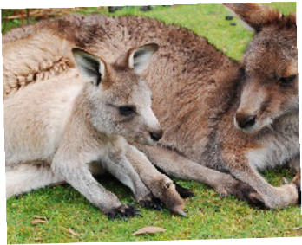
Did you know...?
Kangaroos cannot move backwards and adult kangaroos can live for months without drinking anything at all.

