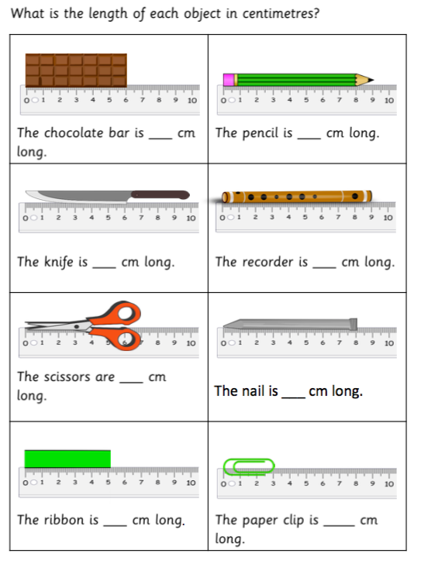
23.2.21 Can I measure using standard units of measure?

*Challenge
If the pictures are not an exact number of cm, measure to the nearest whole cm.

