07.01.2021 Literacy Focus
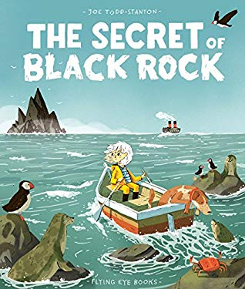
Can I ask questions and make predictions?

