24.2.21
Can I understand what is meant by the “natural world” and suggest some ways to look after it?
Draw some of your favourite things from the natural world…

…then suggest some ways to help look after these parts of it!
The oceans
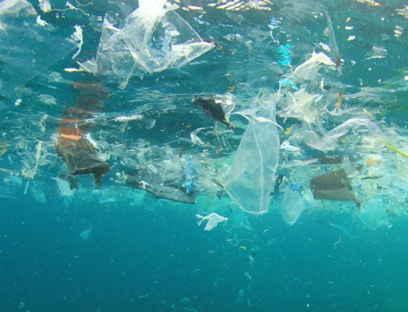

The countryside
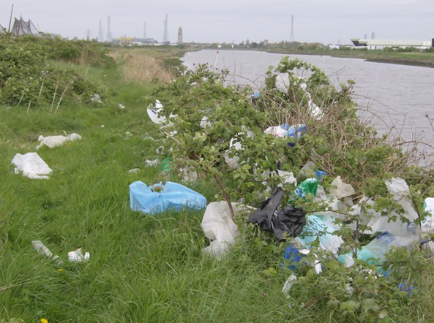

Forests
