Complete the table
Equal groups | Draw it | Addition | Multiply
2 equal groups of 6 | 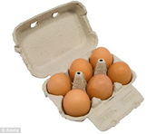 | 6 + 6 =12 | 2 x 6 = 12
3 equal groups of 4
6 equal groups of 2
3 equal groups of 3
4 equal groups of 3
5 equal groups 4

Challenge!! Draw an example of your own set of equal groups and write down the number sentence as an addition and multiplication sentence.

