Learning Objective: Can I generate adjectives to describe how Noi is feeling?

Part One.

“One night, a great storm had raged around their house.
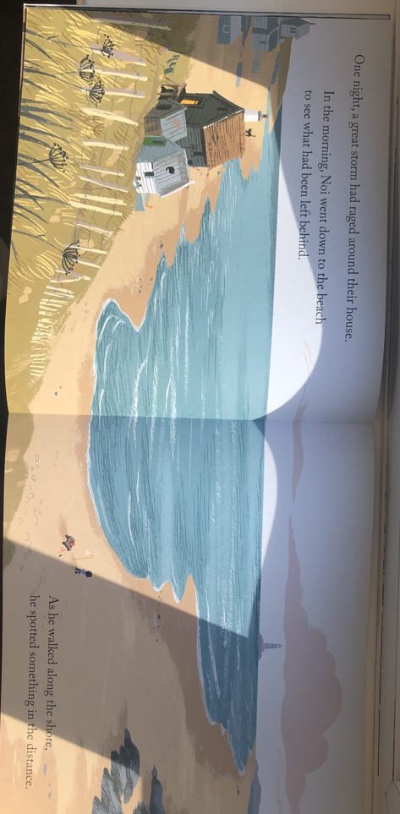
in the morning, Noi went down to the beach to see what had been
left behind. As he walked along the shore, he spotted something

For example: frightened.

in the distance.

For example: excited.

Part Two
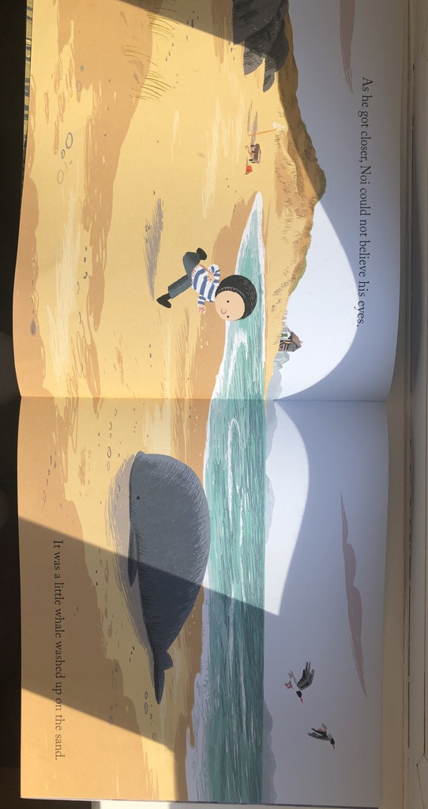
“As he got closer, Noi could not believe his eyes.
It was a little Whale washed up on the sand.”

CHALLENGE: Why is Noi feeling this way?
Part Three

For example: cheerful.

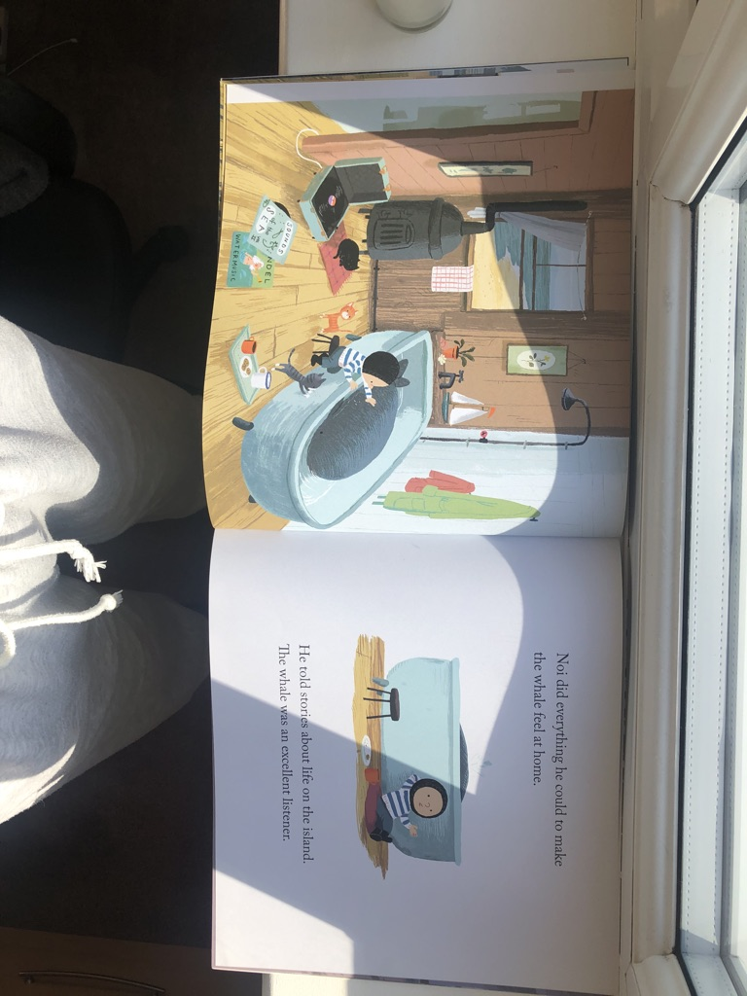
“Noi did everything he could to make the whale feel
at home. He told stories about life on the island. The
whale was an excellent listener.”

CHALLENGE: Why is Noi feeling this way?
Part Four

For example: cheerful.

“ Noi’s dad wasn’t angry. He had been so busy,
he hadn’t noticed that Noi was lonely. But he
said they must take the whale back to the,
where it belonged.”

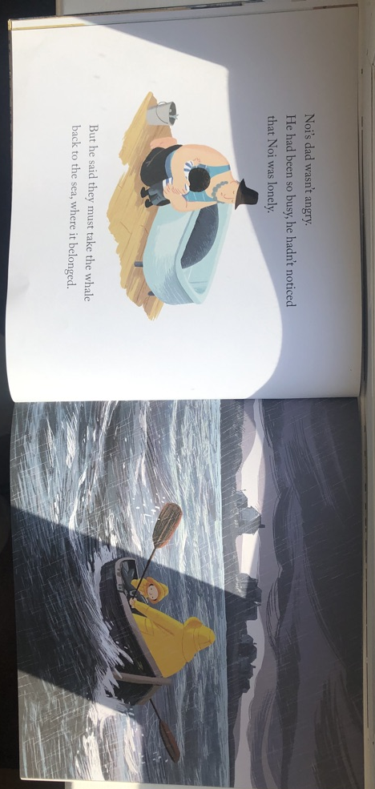

CHALLENGE: Why is Noi feeling this way?

